
Graydays Environmental Ltd store old oil in a large tank. They have noticed that the tank seems
to leak a bit on hot days. They thought this might be because the oil got runnier when it was hot.
A scientist who works for Graydays did an experiment to find out.
This is the apparatus she used.
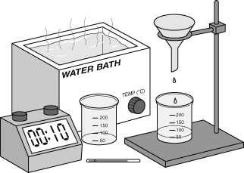   Wear eye protection. | Temperature (°C) | Time for oil to run through funnel (seconds)
 | Temperature (°C) | Results 1 | Results 2 | Results 3
 | 22 | 138 | 124 | 132
 | 30 | 55 | 52 | 57
 | 40 | 35 | 33 | 36
 | 50 | 25 | 24 | 27
 | 60 | 22 | 23 | 21
 | 70 | 20 | 19 | 20
 | 80 | 19 | 19 | 18
If you had to do this experiment, describe what you would do. You should write three or four sentences.
- The scientist’s experiment was a fair test. What did she keep the same each time?
- Why was the experiment repeated three times?
- Why do you think the coolest temperature was 22 °C?
- Work out the mean (average) time for each temperature, and put your answers in a table like this:
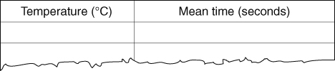
Work out the mean by adding all three results together, and then dividing by 3. Write your answers to one decimal place.
a Plot a graph of the results. Use axes like this:  b Draw a smooth curve through the points on your graph.  Was the oil runniest at 80 °C or 22 °C?  a Write a conclusion for this experiment that describes what was found out.  b Why does the tank at Graydays leak on hot days? | 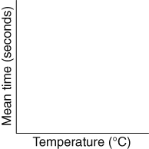
Optional extra
- Find out what term is used to describe how well liquids flow.
I can…
- calculate means
- draw a scatter graph
- use data from graphs
- draw a conclusions and describe relationships from evidence.

