Bacteria have soft cell walls but the structure of these is different in different species. The diagram on the right shows the two main types of cell wall found in bacteria.  It is possible to tell what sort of cell wall a bacterium has using the Gram staining technique. In this process, bacterial cells are placed on a microscope slide and are ‘fixed’ (made to stick to the slide). A stain called crystal violet is then added and washed off, and then iodine solution is added. In the cytoplasm of the cells, the iodine sticks to the crystal violet molecules and forms a purple substance (which is usually just called CVI – crystal violet iodine).  The CVI is trapped inside the cell by thick cell walls or by an outer membrane. Next, the cells are washed in ethanol, which strips away the outer membrane, allowing the CVI to be washed out of those cells and making their cytoplasm colourless. Cells that still contain CVI are said to be ‘Gram positive’ and those that do not are said to be ‘Gram negative’. | 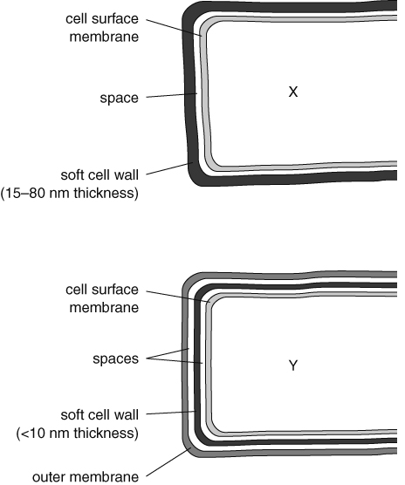
- Name one process that always occurs in the cytoplasm of bacterial cells.
- What is the function of the soft cell wall in bacteria?
- What is the function of the cell surface membrane in bacteria?
- The outer membrane (which is outside the cell wall) in some bacteria has some similar functions to the cell surface membrane. What can you say about the permeability of this membrane to:
- crystal violet
- iodine solution
- CVI?
Explain your reasoning.
- Which of the diagrams above shows a Gram negative bacterium? Explain your reasoning.
- The bacteria in the table can all cause blood poisoning (septicaemia). If you did the Gram test on each of them, what would you see if you looked down a microscope at the slides?
  Bacterium | Cell wall thickness (nm)
  Escherichia coli | 6.4
  Pseudomonas aeruginosa | 2.4
  Staphylococcus aureus | 35.0
- Safranin is a red stain that stains the cytoplasm of all cells a pink colour. Suggest why bacteria fixed to a slide are often soaked with safranin after the Gram test.
- Suggest why the Gram test is important in hospitals.
I can…
- describe how the Gram test is used to tell bacteria apart.

