Name Class Date
To make wine, grape juice and sugar are mixed together and yeast cells are added to ferment it. A winemaker took samples of his wine as it was fermenting and counted the number of yeast cells in each sample. The graph shows the winemaker’s results. | 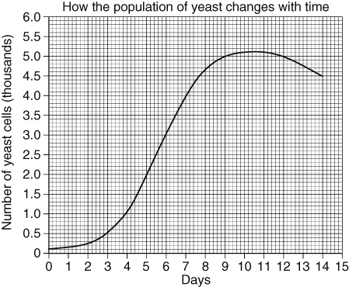
- a What is fermentation? Use the word ‘respiration’ in your answer.
b Copy and complete this word equation for fermentation:
glucose → + .
c Why is fermentation described as being an anaerobic process?
- How do yeast cells reproduce? Give your answer as a labelled diagram.
- How many yeast cells were in the sample that the winemaker took after:
- 2 days
- 7 days
- 9 days?
- How many yeast cells would you expect to find after 15 days?
- The rate of growth of a population is the speed at which it increases.
Rate of growth between days 6 and 8 =$\frac{\text{number on day 8}−\text{number on day 6}}{\text{number of days}}$
=$\frac{\text{4600}−\text{3000}}{2}$=$\frac{\text{1600}}{2}$= 800 cells/day
Calculate the rate of growth of the yeast population between days 4 and 7.
- Explain how the rate of growth of the population might be affected if:
- the wine was kept at a lower temperature
- more sugar was added to the wine before it was allowed to ferment.
- After 7 days, the rate of growth of the population started to slow. Suggest a reason for this.
- What is the name for a factor that causes a population to stop increasing?
- After day 11, the population of living cells decreases. Suggest why.
I can…
- explain what happens in yeast fermentation
- explain how populations can be controlled.

