
- Cut out the cards and match the names of the fuels with the pictures. Some fuels have more than one picture, and some pictures can go with more than one fuel.
- Work with a partner to sort the cards into groups. Be ready to explain how you chose your groups.
- If you have time, try to group the cards in more than one way.
I can…
- recall some different fuels and how they are used.

petrol and diesel | oil |  | butane (the gas used in camping stoves) |  | wood
hydrogen | uranium |  | natural gas |  | animal wastes
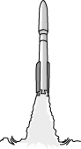  Rocket |  | 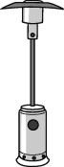  Patio heater |  | 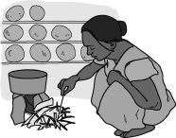  Fire
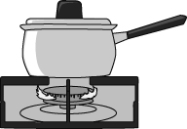  Cooker |  | 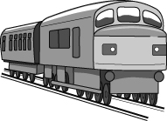  Train |  | 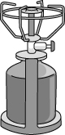  Camping stove
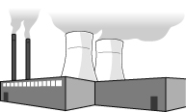  Power station |  | 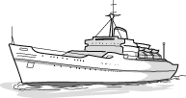  Ship |  | 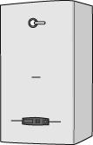  Central heating boiler
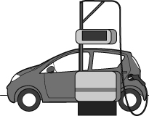  Car |  | 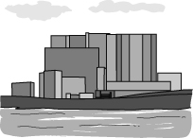  Nuclear power station |  | 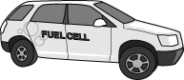  Fuel cell car

