Your teacher may watch to see if you can:
- read the scale on a thermometer
- burn fuels safely.
Aim  To compare the energy released by different fuels.  Hypothesis  Different fuels release different amounts of energy when they burn. |  Wear eye protection.  Wash hands after  handling the fuels.
Apparatus  - boiling tube ● tongs  - clamp and stand ● thermometer  - tin lid ● water  - heatproof mat ● measuring cylinder  - solid fuels ● stop clock  - Bunsen burner ● eye protection | 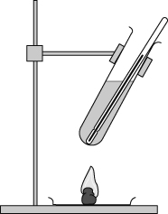
Planning
- Decide which fuels you are going to test, and how much of each fuel you will use.
- Write a method to describe how you are going to carry out your investigation. How long are you going to let the fuels burn?
- How are you going to make your investigation a fair test?
- Draw a table for your results, like this:
Fuel | Temperature of water at start (°C) | Temperature of water at end (°C) | Temperature change (°C)
- Now carry out your investigation. You can light your fuels by holding them in the flame from a Bunsen burner.
Considering your results/conclusions
- Which fuel provided the most heat energy?
- Were any fuels more difficult to light than others?
- a Did any fuels leave soot on the boiling tube?
b Which one burned the most cleanly?
- Which fuel was the best for heating water? (You need to think about your answers to questions 6, 7 and 8.) Explain why this fuel was best.
Evaluation
- How could you improve your investigation if you had time to do it again?
I can…
- plan and carry out a fair and safe test
- draw a conclusion
- evaluate my method.

