Name Class Date
Your teacher may watch to see if you can:
- read the scale on a thermometer
- burn fuels safely.
Aim
To compare the energy released by different fuels.
Hypothesis
Different fuels release different amounts of energy when they burn.
Method
Label this diagram using words from the apparatus list.  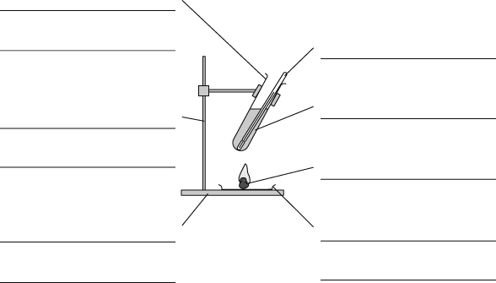  Fill in the missing words, using the words in the box at the bottom of the page. | Apparatus  - boiling tube  - clamp and stand  - tin lid  - heatproof mat  - solid fuels  - Bunsen burner  - tongs  - thermometer  - water  - measuring cylinder  - stop clock  - eye protection   Wear eye protection.  Wash hands after handling  the fuels.
A I will use different solid fuels to some water in a tube.
B I will make it a fair test by using the amount of water each time.
C I will measure 20 cm³ of water using a and pour it into the boiling tube. I will measure the temperature of the water.
D I will light the fuel by holding it in the flame of a .
E I will put the burning fuel under the boiling tube. After 5 minutes I will find the temperature of the water using a .
F I will repeat the experiment with the other . I will make sure I place the burning fuel the same from the boiling tube.
boiling Bunsen burner distance fuels heat
measuring cylinder same thermometer
Recording your results
Fuel | Start temperature of water (°C) | Temperature of water after 5 minutes (°C) | Change in temperature (°C)
- Calculate the temperature change for each fuel and write it in the table.
- The fuel that gave the largest rise in temperature was .
- The fuel that was easiest to light was .
- Some fuels leave soot on things when they burn.
The fuel that burned with the smallest amount of soot was .
Considering your results/conclusions
- The best fuel for heating water is .
This is because

Evaluation
- Write down the letters of the instructions that made sure you did a fair test.
- Is there any way you could have made your investigation better? If so, describe what you could have done.

I can…
- carry out a fair test
- draw a conclusion.

