Name Class Date
- Fill in the gaps in these sentences using words from the box.
Fuels are stores of or nuclear energy. Coal, .
and natural gas are called fuels. They are formed from the remains of plants and . The remains were buried under layers of
, and took of years to turn into fuel. We use fossil fuels and fuels in power stations to generate
. They are fuels because they cannot be replaced once they are used up.
Biofuels are fuels made from , wastes from animals or used cooking oil. They are fuels, because they will not run out.
animals chemical electricity fossil fuel millions
non-renewable nuclear oil plants renewable rock
- The diagrams show how coal, oil and natural gas are formed. Fill in the labels using words from the box. You will need to use some words more than once.
coal gas oil plants rock rot sea
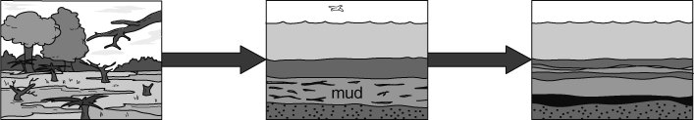
dead plants buried in mud changes to
growing in a swamp mud so they do and plants
not change to
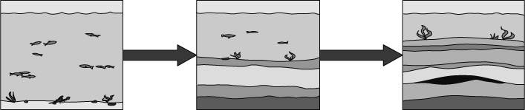
tiny animals and buried in mud so mud changes to
plants in the they do not and fossils
change to
and
I can…
- recall how fossil fuels formed
- state what biofuels are.

