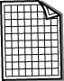
Electricity is not a fuel. Electricity is generated using other energy resources. The pie charts show which fuels were used to generate electricity in the UK in different years. ʻOtherʼ includes renewable resources. A percentage shows how much of each fuel was used compared to the total amount of fuel used that year. Showing percentages helps us to make comparisons between the relative amounts of the different fuels used.
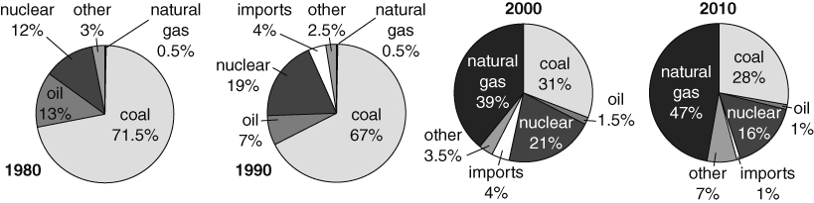
- Which fuel was used the most in 1980?
- Which fuel was used the most in 2010?
- a For which fuels has the percentage increased since 1980?
b For which fuels has the percentage decreased?
- Draw a circle in your book and sketch a pie chart to show which energy resources you think we will be using to generate electricity in 2020.
- The table shows the amount of energy used to generate electricity in 2005.
Fuel | Coal | Oil | Nuclear | Imports | Other | Natural gas
Stored energy used (GWh) | 136 400 | 4000 | 79 500 | 8100 | 20 400 | 158 800
(GWh are units used when the amount of energy is very large. You don’t need to remember them.)
- Copy the table and calculate the percentage of each fuel.
- Draw a pie chart to show this information.
- a Draw a line graph to show how the energy resources we use to generate electricity changed from 1980–2010. Plot the data for each energy resource on the same graph. So that you can tell which points are which, use different symbols to plot each set of data (e.g. +, x, o) or use different colours. Use the axes shown on the graph below (which also shows the line for coal, to give you an idea of what your graph will look like).
b Do you think the pie charts or the line graph show the changes most clearly?
Explain your answer.
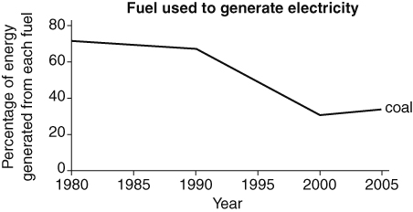
- Optional extra – research project. Find out which fuels are used for generating electricity in:
a France b a country in Africa c a country in Asia.
I can…
- use data from pie charts
- present data as a line graph
- find out about energy resources in other countries.

