Name Class Date
Your teacher may watch to see if you can:
- read the scale on a thermometer
- work safely with burning materials.
Aim
You are going to compare the amounts of energy stored in different foods.
Introduction
Our bodies get the energy we need from the energy stored in food. Different kinds of food store different amounts of energy.
Method
Apparatus  - different kinds of food ● measuring cylinder  - eye protection ● Bunsen burner  - cork ● pin  - water ● thermometer  - clamp stand ● boiling tube |  | 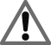 Wear eye protection.  Do not eat any of the foods.
Label this diagram using words from the box. | boiling tube cork food  pin thermometer water
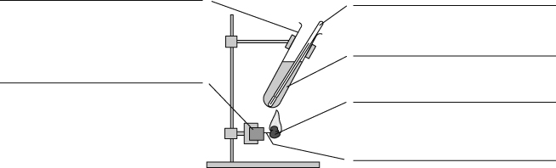
Fill in the missing words using words from the box below.
A I will heat some water using the energy from a .
B I will make it a fair test by using the amount of water each time
and holding the burning food the same from the boiling tube.
C I will measure the volume of the water using a and pour it into a boiling tube.
D I will measure the temperature of the water using a .
E I will the experiment with the other foods.
distance measuring cylinder piece of food repeat same thermometer
Recording your results
- Record your results in the table.
Food | Temperature at the beginning (°C) | Temperature at the end (°C) | Temperature difference (°C)
Considering your results/conclusions
- When the food burned the energy stored in it was transferred to the water and made it hotter.
The food that gave the highest temperature was the .
This is the food which stores the energy.
I can…
- carry out a fair investigation
- draw a conclusion.

