What can you change to use less energy? The changes could be:
- things you do
- things your family do
- changes to your home
- changes to your school
- changes to your area.
Some things you cannot change on your own, but you could write letters or start a campaign to try to persuade other people to help you.
The first thing to do is to find out what could be changed. To do this, you need to find out what happens now.
Work in a group to carry out these tasks.
Task A: Survey
- Choose an area that interests you. There are some ideas here, but you could think of an idea of your own to investigate.
Travel
How often is the family car used? What is it used for? Why don’t people walk, cycle or use public transport instead?
Homes and heating
How hot do people keep their homes? Do they leave the heating on when they go out? Do they have hot baths (which use a lot of hot water), or do they take showers instead? Are their homes insulated?
Food shopping
Some food in the supermarket comes from distant parts of the world. Fuel is used to bring the food to this country. Some foods are flown to the UK, which uses even more fuel than bringing them by ship or road.
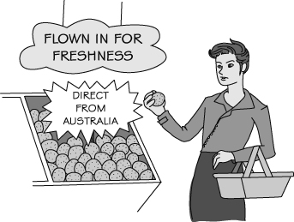
Do people try to buy food that is produced locally? If not, why not? Do supermarkets label the food they sell so that people can make this choice if they want to? Which foods can’t be grown locally?
- Design a survey to find out what people do or think. You will need to think about:
- who you are going to ask
- how many people you need to ask
- what questions you are going to ask them
- how you are going to record their answers.
- Carry out your survey.
Task B: Considering your results
- Look at the results of your survey. You could draw graphs or bar charts to show your results. These can make it easier to think about what you have found out.
- What changes could people make to use less energy? What is stopping them making these changes?
Task C: Action plan
How can you persuade people to change? Do you need to persuade the people themselves, or does something else need to change?

I can…
- describe some ways of using less energy
- work as a team to design and carry out a survey.

