We need to reduce the amount of energy we use, so that we put less carbon dioxide into the atmosphere. There are lots of different things we could do, but we can’t always do everything at once. So how do we decide where to start?
One way of deciding is to try to change things that would make the most difference. The pie charts show how much energy is used for different purposes in the UK.
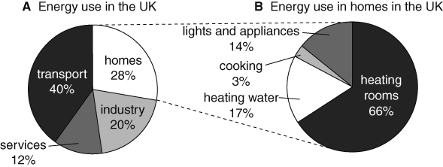
- Look at chart A.
a Where is most energy used?
b Suggest two different ways of reducing the amount of energy used for this purpose.
- Mr Jones says that there is no point in trying to use less energy until factories reduce the amount of energy they use.
What could you say to Mr Jones to persuade him that people can make a difference at home?
- Which would save the most energy: reducing the amount of energy used for heating water by half, or reducing the amount of energy used for heating rooms by half?
- Most homes have a properly insulated hot water tank, but many houses are not properly insulated.
a Why should people insulate their houses before they insulate their hot water tanks?
b Suggest why people usually insulate their hot water tank first.
- Who do you think is right: Mr Green or Ms Goody? Explain your answer.
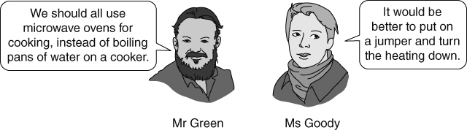
I can…
- suggest ways in which our use of energy can be reduced
- evaluate ways of reducing consumption of fossil fuels.

