- Give one advantage and one disadvantage of using:
a fossil fuels
b nuclear energy
c renewable resources
- The list shows some ways in which energy can be stored. Suggest how energy can be transferred from these stores to electricity.
a kinetic energy
b gravitational potential energy
c chemical energy
d thermal energy
e nuclear energy (stored in the Sun)
- An advert for petrol describes it as ʻliquid sunshineʼ. Explain why this statement could be said to be scientifically correct.  - Part of the label on a new washing machine is shown on the right.  The machine uses 3800 kJ of energy for every wash cycle.  a What does efficiency measure?  b Another washing machine has an A energy rating. How much energy does this one use for the same wash cycle? Choose from: 3200 kJ, 3800 kJ, 4400 kJ.  c Explain your answer to part c.  - It often costs more to buy a more efficient machine, but there are benefits to spending the extra money.  a Suggest one benefit to the person buying the machine.  b Suggest one benefit to the environment.  - a Explain why a normal car adds carbon dioxide to the atmosphere when it is being driven.  b Explain why Mrs Warner is adding carbon dioxide to the atmosphere when she drives her electric car.  c Why does it matter that extra carbon dioxide is being added to the atmosphere? | 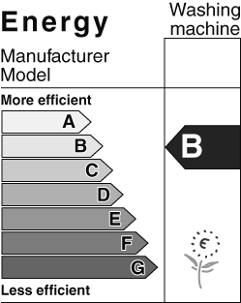  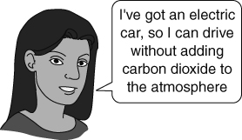
I can…
- identify the energy changes involved in some renewable resources
- explain the ultimate source of energy in fuels
- describe the benefits of using more efficient machines.

