Name Class Date
- Look at the picture of a theme park.
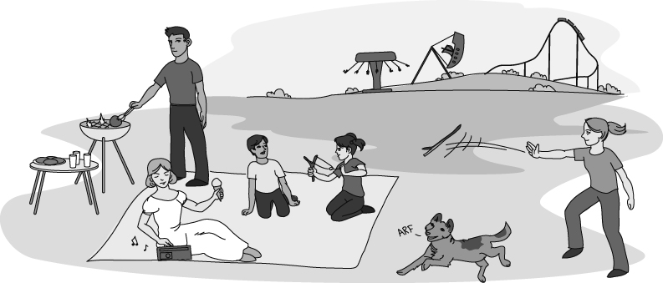
a Label with a C all the things that store energy in chemicals.
b Label with a G all the things that are stores of gravitational potential energy.
c Label with a K all the things that store energy because they are moving (we call this kinetic energy).
d Label with an H all the things that are transferring energy by heating.
e Label with an S all the things that are transferring energy by sound.
f Label with an F all the things that are transferring energy by forces.
- Complete the flow charts to show energy is transferred in each situation. The first one has been done for you.
a
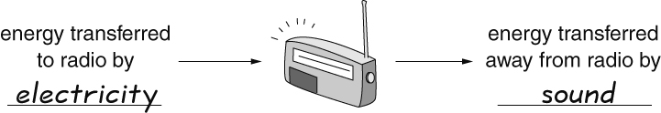
b
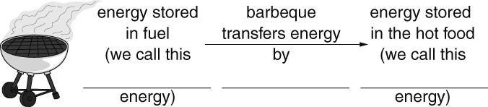
c
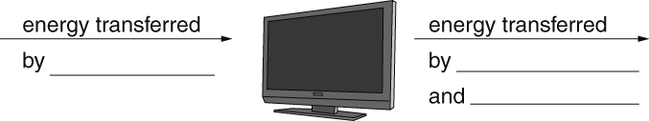
I can…
- identify some ways in which energy is stored and transferred.

