- Look at the picture of a theme park.
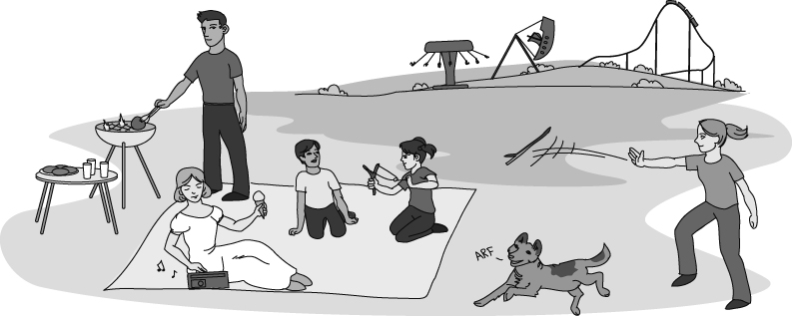
a Write a list of all the things that store energy in chemicals.
b Which things are stores of gravitational potential energy?
c Which things are stores of kinetic energy?
d Which things are transferring energy by heating?
e Which things are transferring energy by sound?
f Which things are transferring energy by forces?
- The flow chart shows the energy being transferred to and from an electric fire.
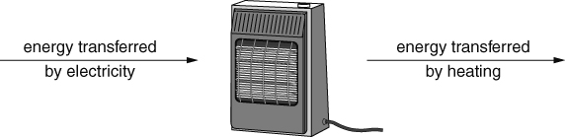
a Where is the energy that enters the fire transferred to? How is the transferred energy then stored?
b How does the amount of energy in these final stores compare to the amount of energy that is transferred to the fire? Explain your answer.
c Draw a flow chart similar to the one above to show how energy is transferred in and out of a television.
I can…
- identify some ways in which energy is stored and transferred.

