Habitats and environments
A habitat is the area where an organism lives. The conditions in a habitat are called the environment. An environment is affected by non-living factors (e.g. light, dampness, temperature), called physical environmental factors.
Physical environmental factors change from day to day (daily changes). As the conditions change, the organisms respond. For example, nocturnal animals are only active at night.
Physical environmental factors change over the year (seasonal changes). Organisms respond to these changes. For example, in autumn some birds migrate to warmer countries to feed during the winter.
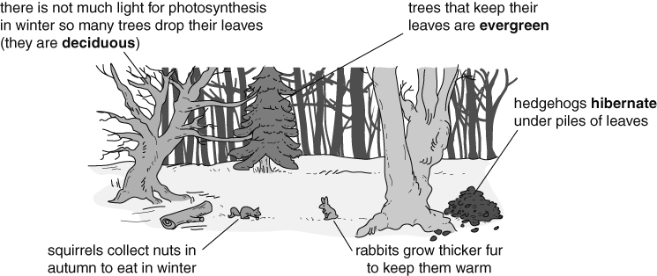
To survive in a habitat, organisms need resources. An animal needs space, food, water, shelter and a mate to reproduce. Plants need space, light, water and mineral salts.
All the organisms in a habitat form a community. Within a community, the total number of one species is called a population.
Adaptations
Organisms have adaptations that allow them to survive in a habitat. For example, fish are adapted to living underwater. They have gills to take oxygen out of the water, fins to swim with and streamlined bodies to help them move easily through the water. Organisms that are better adapted to survive in an area will have a better chance of survival. | 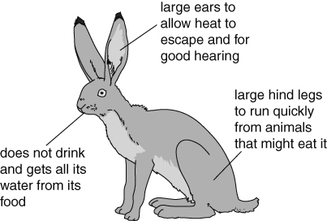  Jackrabbits are adapted to living in a desert habitat.
Populations
The size of a population is affected by several factors.
- Organisms compete with each other for resources. Competition for resources may cause populations of some organisms to decrease.
- Disease can kill organisms.
- Poisons may kill organisms, or kill the organisms that they depend on. Some pesticides are persistent and can build up in the animals as you go along a food chain, harming the top predators.
- Changes in one population affect other populations. When there are a lot of prey organisms, the number of predators increases because they have plenty of food. This decreases the number of prey, which then leads to a decrease in the number of predators.
Food chains and webs
Food chains show what eats what in a habitat. However, organisms depend on other organisms in other ways. For example, many birds depend on trees in which to build nests. | 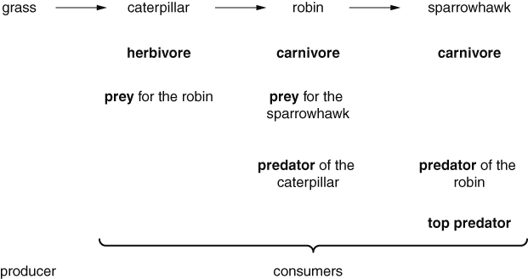
Food chains are joined to form food webs. Food webs can also show omnivores (animals that eat both plants and other animals).
The populations of the organisms at each level in a food chain can be shown as a pyramid of numbers. The size of each bar represents the number of organisms. Usually there are fewer organisms as you go along a food chain because energy is lost at each level (e.g. through movement, keeping warm, in waste materials).
Variation
A species is a group of organisms that can reproduce with one another to produce offspring that will also be able to reproduce. The differences between organisms are known as variation. There is variation between different species and between members of the same species. Variation that has a continual range of values is continuous variation (e.g. height). Variation that only has certain values is discontinuous variation (e.g. blue, brown or green eyes).
Sometimes there is a relationship between two features. A relationship is normally best shown on a scatter graph. A line of best fit can be drawn through the points to show the relationship. | 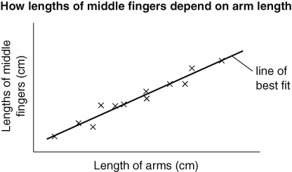  Relationship: people with longer arms have longer middle fingers.
Environmental variation is variation caused by the environment. In humans, sunburn and having a scar are examples of environmental variation. Plants are affected by environmental factors such as the amount of light, water, warmth or mineral salts in the soil.
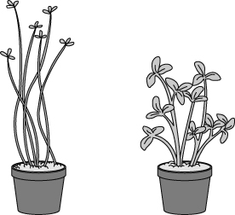  The cress seedlings on the left have not had enough light. | 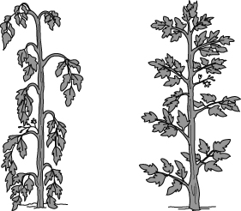  The tomato plant on the left has not had enough water.
Inherited variation is caused by features being passed from parents to their offspring during reproduction. In humans, natural eye colour and natural hair colour are both examples of inherited variation.

