Kingdoms
Organisms are classified into five kingdoms. Viruses are not living and so are not in a kingdom.
Cell part | Kingdom
Cell part | prokaryotes (all unicellular) | protoctists (mainly unicellular) | fungi (mainly multicellular) | plants (all multicellular) | animals (all multicellular)
cytoplasm | ✓ | ✓ | ✓ | ✓ | ✓
cell membrane | ✓ | ✓ | ✓ | ✓ | ✓
nucleus | ✗ | ✓ | ✓ | ✓ | ✓
mitochondria | ✗ | ✓ | ✓ | ✓ | ✓
cell wall | ✓ | ✗/✓ | ✓ | ✓ | ✗
chloroplasts | ✗ | ✗/✓ | ✗ | ✓ | ✗
Unicellular organisms can only grow to a certain size. If the organism is too big, it cannot get enough of the substances it needs throughout the cell because diffusion is too slow.
The tissues in multicellular organisms need to have raw materials transported to them because diffusion would be too slow.
Microscopic fungi  These include, for example, yeast. They:  - reproduce asexually by budding  - can use aerobic respiration, which is important in baking  - can use anaerobic respiration  (fermentation), which is important in  alcoholic drink manufacture. | 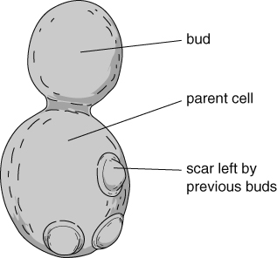
glucose → carbon dioxide + ethanol (alcohol)
Bacteria
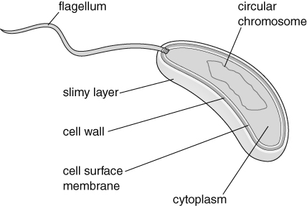
Parts of a bacterium
Some bacteria are important in making yoghurt and cheese. These bacteria use a type of anaerobic respiration to ferment milk:
glucose → lactic acid
Feeding
Bacteria and fungi feed by releasing enzymes into their surroundings to digest large organic molecules. The digested molecules are then absorbed.
Protoctists
There are many different types of protoctist and some can photosynthesise:
carbon dioxide + water → glucose + oxygen
Photosynthesising protoctists are therefore producers in a food chain, for example:
algae | → | pond snail | → | minnow | → | grey heron
(producer) |  | (consumer, herbivore) |  | (consumers, carnivores, predators)
Some protoctists move using pseudopods, while others use cilia and others use flagella.
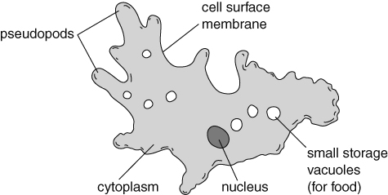
Parts of an Amoeba
Growth
All microorganisms need warmth, food and moisture to grow well. Some need light for photosynthesis. Some need oxygen for aerobic respiration. The increase in a population can be shown on a growth curve. Something that stops a population from increasing further is called a limiting factor. | 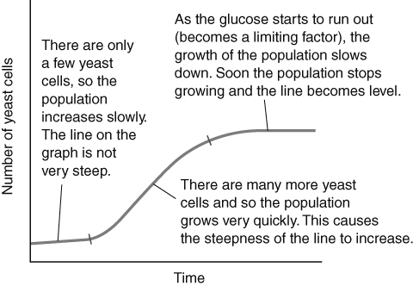
The carbon cycle
Many unicellular microorganisms are decomposers and play an important part in the carbon cycle. | 