Earth and space
The Solar System
We live on a planet called the Earth. The Earth gets energy from the Sun. The Earth spins on its axis once every 24 hours. The side of the Earth facing the Sun has daylight, and it is night on the side facing away from the Sun.  The Earth orbits around the Sun. It takes one year to go around once.  The Moon is a satellite of the Earth. We can see the Moon because it reflects light from the Sun. The Moon seems to change shape. The different shapes are called phases of the Moon. The phases happen because we cannot always see all of the part that is lit by the Sun. | 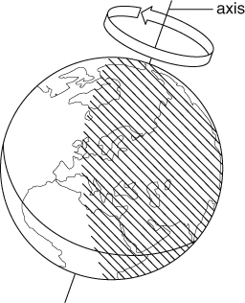
There are eight planets in elliptical (oval-shaped) orbits around the Sun. Most of the planets have moons orbiting around them. The Sun, the planets and their moons make up the Solar System.  The eight planets are Mercury, Venus, Earth, Mars, Jupiter, Saturn, Uranus and Neptune. | 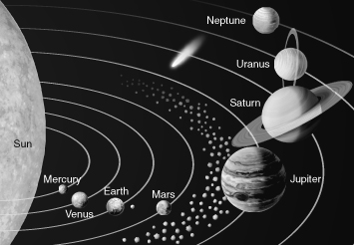  Our current model of the Solar System
The Earth’s axis is tilted. When the northern hemisphere is tilted towards the Sun it is summer in the UK. Days are longer than nights, and the Sun is higher in the sky. The Sun’s rays are more concentrated, so it feels hotter.
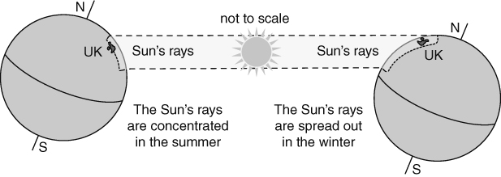
Magnets and magnetic fields
Magnets attract magnetic materials. The two ends of a bar magnet are called the north-seeking pole and the south-seeking pole, or north pole and south pole for short. A north pole and a south pole attract each other. Two north poles or two south poles repel each other.
The space around a magnet where it has an effect is called its magnetic field. You can find the shape of the magnetic field using iron filings or using a plotting compass.  The Earth has a magnetic field. A compass is a small magnet that will point towards the Earth’s North Pole. But magnetic materials placed near a compass can change the direction that the compass points towards. | 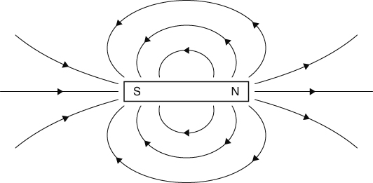  This is the shape of the magnetic field of a bar magnet.

Gravity and gravitational fields
The mass of something is the amount of substance or ‘matter’ it contains. It is measured in kilograms (kg). Weight is the force of gravity pulling on a mass. It is a force, so it is measured in newtons (N).
Gravity is the force of attraction between two masses. The force of gravity is stronger if:
- the objects have large masses
- the objects are close together.
On Earth, gravity pulls on every kilogram of mass with a force of about 10 N.
Gravity is not as strong on the Moon because the Moon has a much smaller mass than the Earth. If you went to the Moon your mass would not change, but your weight would be less than on Earth because the Moon’s gravity is weaker.
You can calculate the weight of an object using this formula:
weight (N) = mass (kg) × gravitational field strength (N/kg)
The Sun’s gravity keeps all the planets in our Solar System moving in elliptical orbits around it. If there was no gravity from the Sun, the planets would all fly off into space. The Earth’s gravity keeps the Moon in orbit around the Earth.
A satellite is anything that orbits around a planet. The Moon is the only natural satellite of the Earth. Artificial satellites are put into orbit around the Earth or other planets. They can be used for taking pictures or transmitting TV programmes. | 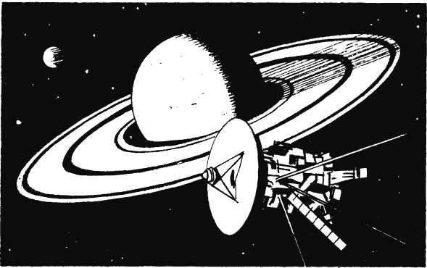
Beyond the Solar System
Planets do not make their own light. We can sometimes see the planets because they reflect light from the Sun.
The Sun is a star. It is a ball of gas that gives out large amounts of energy. The Sun is like the stars you can see in the sky at night. The stars do not look very bright because they are a lot further away than the Sun. People often group stars into patterns called constellations.
The Sun is one of millions of stars in our galaxy, which is called the Milky Way. There are millions of galaxies in the Universe.
The stars are a very long way from Earth. Scientists measure distances to the stars using light years. A light year is the distance that light can travel in one year.

