Energy transfers
Energy and temperature
When we know the temperature of something, we know how hot it is, not how much internal energy (thermal energy) is in it.
Temperature is measured in degrees Celsius (°C).
Internal (thermal) energy is measured in joules (J).
The amount of thermal energy stored in something depends on:
- how hot it is (its temperature)
- the material it is made from
- its mass.
When two objects are at different temperatures, energy will be transferred from the hotter one to the cooler one until they are at the same temperature.
Transferring energy by heating
Energy can be transferred by heating in different ways.
Evaporation can take place from a liquid at any temperature. When part of a liquid evaporates, it is the fastest-moving particles that escape to form a gas. The particles that are left are storing less energy as movement and so the temperature of the remaining liquid is lower.
Conduction takes place in solids and can also happen in liquids (although not very well). The particles in a solid are held together tightly. When they gain energy they vibrate faster and further, and the vibrations are passed on. Metals are the best conductors. Most other solids are poor conductors.
Particles are not as close in a liquid, so conduction is not very good. Particles are a long way apart in gases, so gases hardly conduct heat at all. Something that does not conduct heat very well is a thermal insulator. Liquids, gases, and solids that contain a lot of trapped air are insulators.
Convection takes place in fluids (liquids and gases). When part of a fluid is heated, the particles spread further apart and the fluid becomes less dense. This makes it rise. As it rises it meets cooler fluid and passes the energy on. More cool fluid moves in to replace the rising fluid, setting up a convection current. | 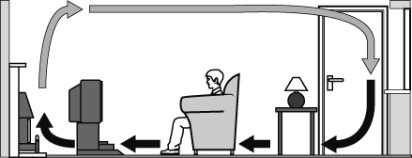
Infrared radiation can transfer energy through empty space and also through transparent materials. Radiation does not require the movement of particles. Any hot or warm object gives off or emits radiation. When something takes in energy from radiation, it is said to absorb it.
Infrared radiation is similar to light. It can be absorbed or reflected, and it can also be focused.
Dark, dull surfaces are good emitters and absorbers of radiation. Light, shiny surfaces are good at reflecting radiation. They are poor absorbers and emitters of radiation.
Power
Power is the rate at which energy is transferred. Power is measured in watts (W) or kilowatts (kW). One watt is one joule of energy being transferred each second. 1000 W = 1 kW.
Efficiency
Not all energy is transferred usefully. Wasted energy is often transferred by heating. The percentage of useful energy produced by something is known as its efficiency.
efficiency = $\frac{\text{useful energy transferred}}{\text{total energy supplied}}$× 100%
The Sankey diagram shows the energy transfers in a kettle. The width of each arrow shows the amount of energy it represents. The energy stored in the kettle and the surroundings is wasted energy.  efficiency of kettle = $\frac{\text{1600 J}}{\text{2000 J}}$× 100%  = 80% | 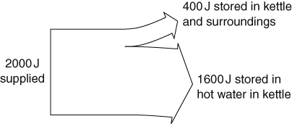
Paying for energy
We pay for the amount of energy we use in our homes. Electricity companies use units of kilowatt-hours on electricity bills. One kilowatt-hour is the amount of energy transferred when a one kW appliance is used for one hour.
We can reduce bills by insulating our homes and by using more efficient appliances.
The payback time of installing something that makes a home more energy efficient is the time taken for the cost of installation to be matched by the money saved. Sometimes buying a more efficient appliance may not save you energy overall because it costs more to buy than it will save.
payback time = $\frac{\text{cost of change}}{\text{savings per year}}$
Accuracy and precision
A measurement is accurate if it is close to the true value of the thing being measured. Measuring devices that have small divisions can measure more accurately than instruments with larger divisions if they are set up correctly.
A measurement is precise if several measurements of the same thing give similar results. Precise measurements may not be accurate if the measuring instrument was not set up correctly.

