Light
Light travels in straight lines from a source. Light travels as transverse waves. It travels much faster than sound, and does not need a substance to travel through.
Light travels through transparent objects but not through opaque objects. Shadows are made when light is blocked by an object. Opaque objects block all light. Translucent objects allow some light to pass through, but it is scattered so you do not see a clear image.
Transmission and absorption
Transparent materials let light pass straight through. We say they transmit light. Opaque surfaces can absorb or reflect light. White surfaces reflect most of the light that hits them. Black surfaces absorb light very well and reflect very little. This is why they look so dark.
Reflection
Light rays are scattered by rough surfaces (diffuse reflection), which means that you cannot see an image in an object with a rough surface.  Mirrors and shiny materials such as polished metals reflect light evenly. This is called specular reflection. The angle of incidence (i) is equal to the angle of reflection (r) – this is known as the law of reflection. Angles are measured between the light rays and the normal (a line drawn at right angles to the reflecting surface).  You can see an image in a mirror because the reflected rays of light appear to come from a point behind the mirror. | 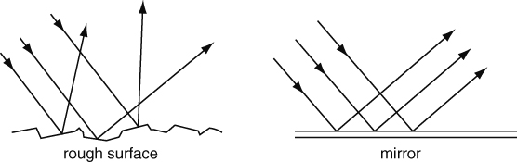  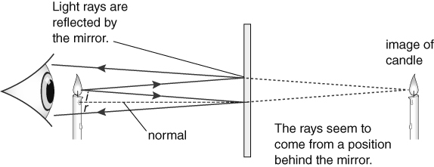
The image in a plane mirror is the same size as the object, and the same distance away from the mirror. In the image, left becomes right and right becomes left.
Refraction
When light hits something transparent it changes speed and direction. This is called refraction. Refraction takes place at the interface between two substances. When light is transmitted through glass it slows down and changes direction towards the normal. When it travels back out it speeds up again and changes direction away from the normal.
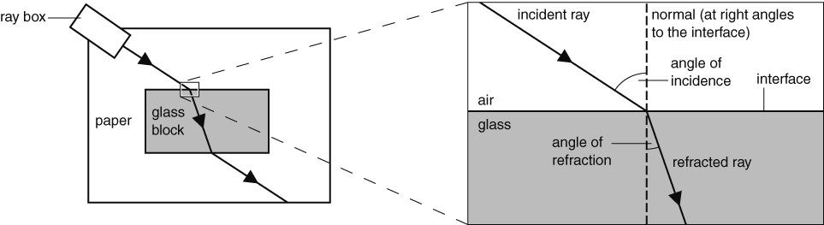
Lenses are curved pieces of glass or transparent plastic that are designed to refract light in particular ways. Converging lenses make rays of light come together. The focal point of a lens is the point where parallel rays of light are brought together by the lens, and the focal length is the distance of this point from the centre of the lens.
Lenses are used in cameras, microscopes and telescopes.
Cameras and eyes
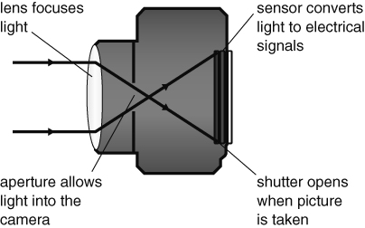 | 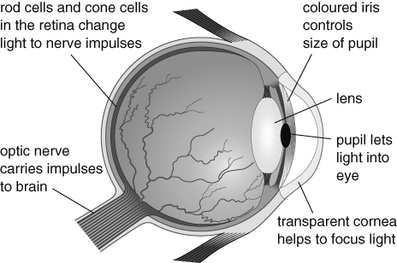
Rod cells in our retinas detect faint light but not colours and cone cells detect the primary colours of red, blue and green. We see combinations of primary colours as secondary colours (magenta, cyan and yellow).
Colour
White light is a mixture of colours. White light can be split up using a prism to give a spectrum of seven colours (red, orange, yellow, green, blue, indigo, violet). The splitting of colour into a spectrum is called dispersion.
We are able to see colours because objects do not reflect all the colours in light. White objects reflect all the colours, but a red object only reflects red and all other colours are absorbed. This idea applies to all colours except black – black objects absorb all colours.
Filters are used to make coloured light. They transmit one of the colours in white light and let the other colours through. If you look at a coloured object in coloured light, its colour may appear to be different.

