Fluids
Fluids are liquids or gases.
The particle model
The particle model can explain the properties of solids, liquids and gases.
 | Solids | Liquids | Gases
Properties | - fixed volume  - fixed shape | - fixed volume  - take shape of container | - expand to fill container  - take shape of container
Particle diagram | 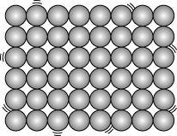 | 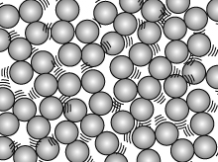 | 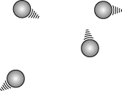
Particles | - are close together  - are held in fixed positions by strong forces | - are close together  - are held by fairly strong forces  - can move around | - are far apart  - are held by very weak forces  - can move around
Density
Density is the mass of a certain volume of something, and it can be calculated using this formula:
density = $\frac{\text{mass}}{\text{volume}}$
The units for density are g/cm³ or kg/m³.
Changes of state
Substances can change state when they are heated or cooled. The three states of matter are solid, liquid and gas.
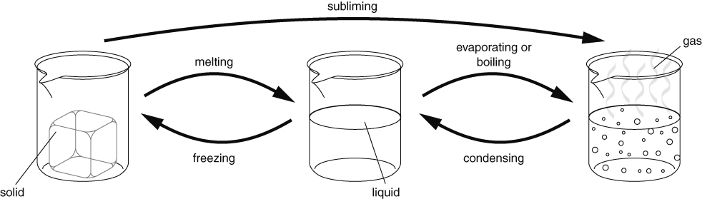
A liquid evaporates from its surface. When it is boiling, bubbles of gas form within the liquid.
The melting point and the freezing point of a substance are the same temperature. The temperature of a substance does not change while it is melting, even if it is still being heated.
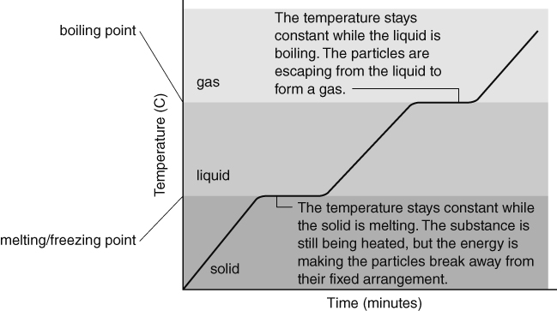
Changing density
Substances expand when they are heated. The particles in a solid vibrate more and take up more space. The particles in liquids and gases move around faster and take up more space. When a material expands its density decreases.
Substances contract when they cool down, as the particles have less energy and do not move as much. This reduces the volume and increases the density. When a liquid freezes and becomes a solid its density increases a lot.
Ice is unusual, because it is less dense than liquid water. This is why ice floats on water.
Pressure in fluids
Both gases and liquids are fluids. Fluids can flow. Pressure in fluids acts in all directions. The particles in fluids are moving all the time and hitting the walls of containers and other things they come into contact with. The force of the collisions causes pressure, which acts in all directions.
The pressure of gas in a container can be increased by:
- putting more particles into the container (so there will be more collisions with the container walls each second).
- heating the gas (so the particles move faster, hitting the walls harder and more often).
- reducing the volume of the container (so the particles do not have as far to go between the walls and so collide with the walls more often).
As you go deeper into the sea, pressure increases because there is more water above you pressing down. If you climb a high mountain, the air pressure on you will get less, because there is less air above you pressing down.
Floating and sinking
You can decide if something will float by working out its density, and the density of the fluid. If the density of the object is less than the density of the fluid, it will float.
The density of water is 1 g/cm³, so objects with densities less than 1 g/cm³ will float in water.
Drag
Drag is another name for air resistance or water resistance. The amount of drag on something can be reduced by giving it a smooth surface and a streamlined shape. The drag increases as the speed increases, so cars use up more fuel per kilometre when they are travelling fast. Drag is caused by particles in the fluid hitting the moving object, and by the force needed for the object to push the fluid out of the way. The particles transfer energy to the object, which is why objects moving through air can get hot.

