Rocks
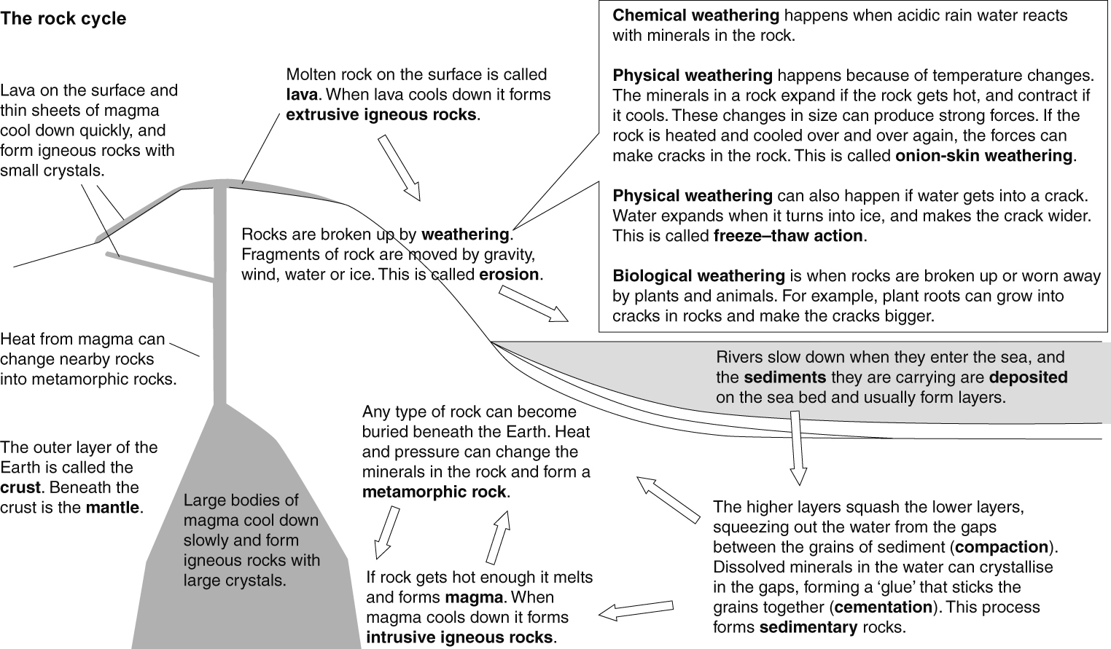
Rock textures
Rocks are made of grains. Each grain is made of a naturally occurring compound called a mineral. The texture of a rock is a description of the size and shape of the grains.
Type of rock | Sedimentary | Igneous | Metamorphic
Examples | limestone, sandstone, mudstone, chalk | basalt, gabbro, granite | marble, quartzite, slate, schist, gneiss
Grains or crystals? | separate grains | interlocking crystals that are not lined up | interlocking crystals, often lined up in bands of different colours
Hard or soft? | often soft or crumbly | hard | hard
Porous? | often | not usually | not usually
Example of texture | 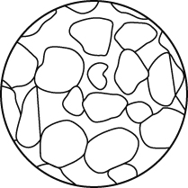 | 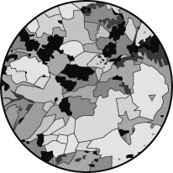 | 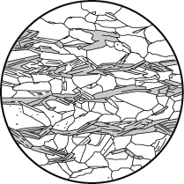
Fossils
Fossils can form when dead plants or animals fall to the bottom of the sea. If their remains get covered by other sediments they do not rot. As the sediments turn into sedimentary rock, the shape of the organism is preserved in the rock. When a dead organism forms a fossil, its form can still be seen because its hard parts have been turned into stone.
Materials from the Earth
Many of the materials we use are obtained from the Earth. We use stone for building. Cement is made from limestone, and concrete is made by mixing cement, sand and gravel with water.
We also obtain metals from the Earth. Unreactive metals like gold and silver are found in their native states. Other metals are found as parts of minerals. An ore is a rock with enough of a particular mineral in it to make it worth mining. Pure metals are obtained from minerals using chemical reactions.
Mining for metals can destroy habitats and cause pollution.
If we recycle metals we will:
- make supplies of metals last longer
- reduce amounts of mining (and so reduce the pollution and environmental damage this causes)
- reduce pollution caused by putting metals in landfill sites.

