The physical properties of metals
Metals | Non-metals
good conductors of heat and electricity | poor conductors of heat and electricity
shiny | dull
solids with a high melting point (except for mercury) | most are low melting point solids or gases
flexible and malleable | brittle (break easily instead of bending)
The chemical properties of metals
The chemical properties of metals refers to their reactions with other substances.
For example, metals can react with many non-metals:
e.g. calcium + chlorine → calcium chloride
(Note: When naming a compound the ending of the non-metal is changed to ide)
Metals can also react with air (oxygen), water and acids. Some metals react very quickly; they are reactive. Calcium is a reactive metal. Other metals do not react quickly; they are unreactive. Gold is a very unreactive metal.
Uses of metals  Metals have many uses depending on their different properties. For example, copper is used in electrical wires as it is flexible and a good conductor of electricity. It is also used for roof sheets as it is malleable and doesn’t react quickly with water. | 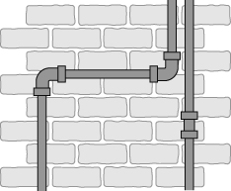
Metals as catalysts
Some metals act as catalysts. These are substances that speed up chemical reactions without being used up themselves. Catalysts have many uses, for example, platinum is used in catalytic converters in cars.
Corrosion and oxidation of metals
The reaction of metals with oxygen forms metal oxides:
metal + oxygen → metal oxide
e.g. word equation: calcium + oxygen → calcium oxide
This is called an oxidation or corrosion reaction.
Some metals like sodium react quickly with water and oxidise immediately when scratched. Other metals do not react easily, for example silver changes colour very slowly as it reacts with oxygen.
Rusting
The corrosion of iron is called rusting. It destroys iron and steel structures because rust is weak and crumbly. Water and oxygen must be present for iron to rust.
iron + water + oxygen → iron hydroxide
Coating the iron with paint, plastic, etc. acts as a barrier to oxygen and water and stops iron rusting.
Metals and water  Some metals can react with cold water.  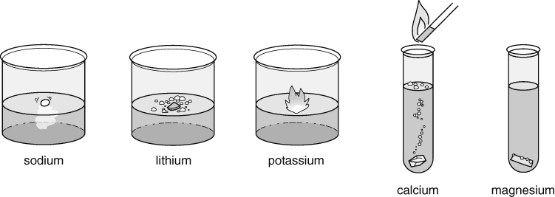  All the metals that react with water form a metal hydroxide (an alkaline solution) and hydrogen gas.  metal + water → metal hydroxide + hydrogen  The test for hydrogen gas is that it burns with a ‘squeaky pop’.  Again, the equations can be written using words or symbols:  Metals and acids  The metals that react with water react very quickly with acids. Some metals that don’t react with water do react with acids. When metals react with acids, they produce hydrogen and a salt.  metal + acid → salt + hydrogen  The name of the salt formed depends on the name of the acid:  - hydrochloric acid → chlorides  - sulfuric acid → sulfates  - nitric acid → nitrates  Again, the equations can be written using words or symbols: | Reactivity series  The reactions of metals with oxygen, water and acids allows us to put the metals in order of reactivity:  Potassium  D  e  c  r  e  a  s  i  n  g  r  e  a  c  t  i  v  i  t  y  Sodium  Lithium  Calcium  Magnesium  Aluminium  Zinc  Iron  Tin  Lead  Copper  Mercury  Silver  Gold  The reactivity of metals can be linked to their uses.  For example, metals used for building need to have a low reactivity, otherwise they will corrode away.
  sodium | + | water | → | sodium hydroxide | + | hydrogen
  2Na | + | 2H₂O | → | 2NaOH | + | H₂
  magnesium | + | sulfuric acid | → | magnesium sulfate | + | hydrogen
  Mg | + | H₂SO₄ | → | MgSO₄ | + | H₂
Alloys
Alloys are mixtures of metals with one or more other elements. Alloys have different properties from the pure metal and so can be more useful.
For example, steel, an alloy of iron, is stronger and does not rust as quickly.
Pure metals have a fixed, precise melting point where as alloys have a lower melting point and melt over a range of temperatures. Melting points can therefore be used to identify pure metals.  Alloys are usually also harder than pure metals because the different sized atoms disrupt the regular structure making it harder for the layers of atoms to slip over each other. | 