Dalton’s atomic theory
Dalton’s theory stated that:
- All matter is made up of tiny particles called atoms.  - Atoms are indestructible, and cannot be created, or destroyed.  - The atoms in an element are all identical.  - In compounds, each atom of an element is always joined to a fixed number of atoms of the other elements.  - During chemical reactions, atoms rearrange, to make new substances. For example:  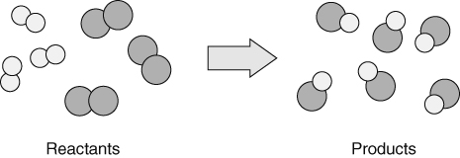  No atoms are lost or gained so the mass of the reactants is equal to the mass of the products. | 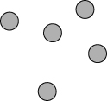  Atoms of an element.  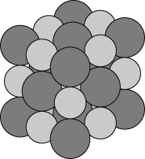  Atoms in a compound.
Word equations
The word equation for the above change is:
hydrogen + chlorine → hydrogen chloride
REACTANTS PRODUCTS
Some signs of a chemical reaction include:
- colour change
- gas produced
- solid formed from solution
- energy change.
Elements and their symbols
The symbols for the elements used today have been agreed by scientists in all countries. They are either a single or double letter. The first letter is always a capital letter. | Examples:  nitrogen = N lithium = Li  sulfur = S copper = Cu  chlorine = Cl iron = Fe
Formulae
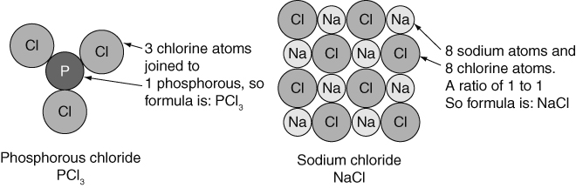 | The chemical formula of a substance tells you the number of atoms of each element that are joined in its molecules, or the ratio of atoms of each element in the compound.

Metals and non-metals
The common properties of most metals are:  - high melting points  - solids at room temperature  - strong and flexible  - malleable  - shiny (when polished)  - good conductors of heat and electricity. | The common properties of most non-metals are:  - low melting point  - brittle(when solid)  - not shiny  - poor conductors of heat and electricity.
The properties of a substance are what it looks like or what it does. There are two types of properties:
- chemical properties (e.g. flammability, pH, reaction with acid)
- physical properties (e.g. melting point, boiling point, density).
The periodic table
The periodic table arranges the elements so that elements with similar properties are in the same vertical group. The periodic table also allows us to spot trends and patterns.
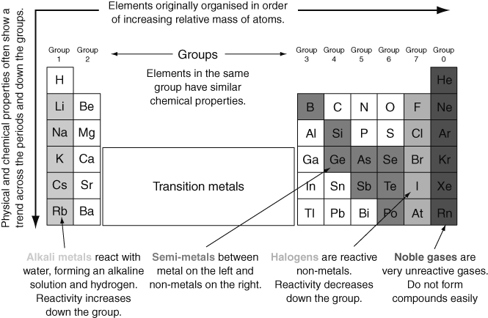
Metal and non-metal oxides
Many elements burn in air/oxygen to form oxides; e.g.:
- calcium + oxygen → calcium oxide • carbon + oxygen → carbon dioxide
- metal oxides tend to form alkaline solutions. • non-metal oxides tend to form acidic solutions.

Changes of state
