Combustion and oxidation
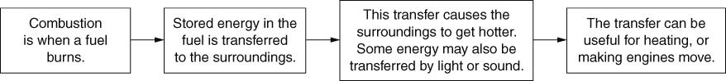
A hydrocarbon is made only of carbon and hydrogen. Many fuels are mainly hydrocarbons.
This is a word equation.
Hydrocarbon combustion:
hydrocarbon + oxygen → water + carbon dioxide
Combustion is also an oxidation reaction because the substances react with oxygen.
Carbon and hydrogen are non-metals but metals can also be oxidised:
metal + oxygen → metal oxide
Conservation of mass in reactions  In a reaction, the mass of the reactants is always the same as the mass of the products.  Metals can appear to gain mass when heated in air:  zinc + oxygen → zinc oxide | 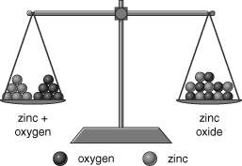
The difference in mass is the mass of oxygen that reacted.
When a hydrocarbon fuel combusts, it appears to lose mass because the products of the reaction (carbon dioxide, water vapour) are lost into the air.
Phlogiston
Before oxygen was discovered, scientists explained combustion by saying that, as a substance burnt, it gave out a substance called phlogiston to the air. For example:
wood → calx (ash) + phlogiston
However, the phlogiston theory could not explain why metals gained mass when they reacted with air.
The fire triangle and putting fires out  The fire triangle shows the three factors needed for a fire to burn. If any factor is removed, the fire will go out.  We use fire extinguishers to put out fires. Water extinguishers remove heat. Powder and carbon dioxide extinguishers exclude oxygen. Foam extinguishers can both remove heat and exclude oxygen. | 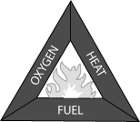
Oil fires should not be treated with water because the water sinks through the oil, which heats up and causes the water to evaporate. This causes the oil to ‘spit’ and can spread the fire.
Hazard symbols
Hazard symbols explain why a substance must be handled carefully.
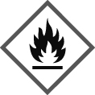
Air pollution from burning fossil fuels
Complete combustion – the fuel reacts completely with oxygen, e.g.:
hydrocarbon + oxygen → carbon dioxide + water
Incomplete combustion – the fuel only partly reacts with oxygen, e.g.:
hydrocarbon + oxygen → carbon dioxide + water + carbon monoxide + carbon (soot)
Impurities in fossil fuels, such as substances that contain sulfur, also react with oxygen when heated:
sulfur + oxygen → sulfur dioxide
At the very high temperatures in vehicle engines, nitrogen gas from the air reacts with oxygen:
nitrogen + oxygen → nitrogen oxides
Many products from burning fossil fuels are pollutants; they harm the habitats and their organisms.
Acid rain
Acid rain is rain water that is made more acidic by dissolved sulfur dioxide and nitrogen oxides. Some of these gases are removed from power station chimneys by neutralisation, and by using catalytic converters on vehicle exhausts. Catalytic converters also remove carbon monoxide (another pollutant).
Greenhouse effect and global warming
Greenhouse gases in the Earth’s atmosphere keep the Earth’s surface warm. This is the greenhouse effect.
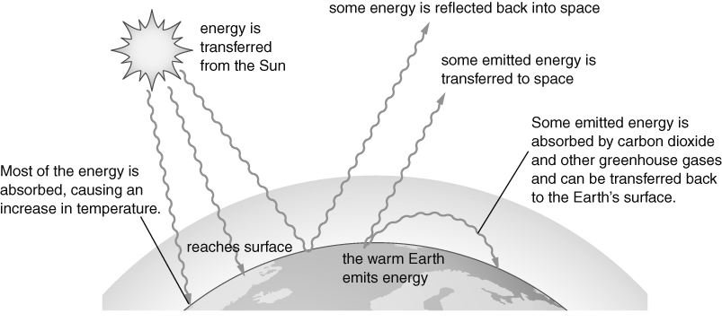
Carbon dioxide is a greenhouse gas. Most scientists think that the extra carbon dioxide released from burning fossil fuels has increased the temperature of the Earth’s surface (global warming).
Scientists predict that global warming will cause climate change. The best way to control global warming is probably to reduce the amount of carbon dioxide we release into the air.

