Types of respiration
All living cells respire to release energy. Organisms need energy for everything they do (for example, making new substances, moving).
Aerobic respiration is a series of chemical reactions that can be summarised as:
glucose + oxygen → carbon dioxide + water
Energy is released (but is not a chemical substance and so is not shown in the word equation).
Carbon dioxide can be detected using:
- limewater (which it turns cloudy)
- an indicator (such as hydrogen carbonate) because it is acidic.
Anaerobic respiration does not require oxygen. In humans it is used to release energy from glucose when more energy is needed than can be supplied by aerobic respiration (for example, during strenuous exercise).
glucose → lactic acid
Anaerobic respiration causes muscles to tire quickly and so cannot be used for extended periods. A lot of the lactic acid travels from the muscles to the liver, where it is converted back to glucose. Anaerobic respiration releases less energy than aerobic respiration.  After strenuous exercise, the body needs extra oxygen. This excess post-exercise oxygen consumption (EPOC) (or ‘oxygen debt’) replaces oxygen lost from oxygen stores (in the blood and in muscles) and provides oxygen for increased levels of aerobic respiration (for example, to provide energy for removing lactic acid, for faster breathing, for faster heart rate). | 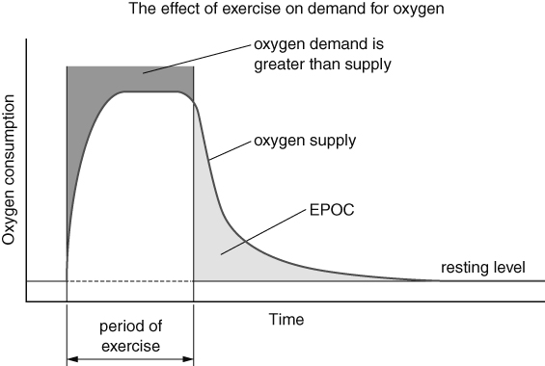
Gas exchange
Different organisms use different organs for gas exchange (swapping one gas for another):
- gills (e.g. fish)  - skin (e.g. frogs) | - stomata in leaves (plants)  - lungs.
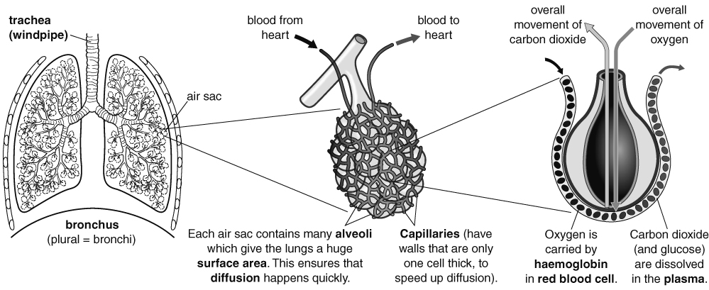
Ventilation and breathing
When you exercise, your breathing rate (number of breaths in one minute) and your pulse rate (number of times your heart beats in one minute) increase. This is because your cells need more oxygen and glucose for respiration.
Breathing is the movement of muscles in the diaphragm and attached to the ribs. These movements change the volume of the chest.
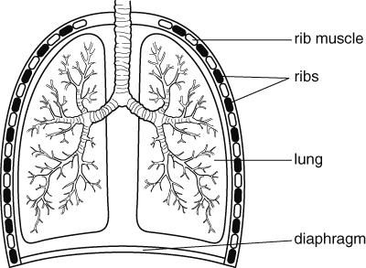 | 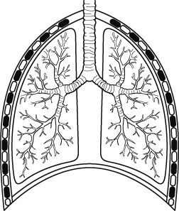
Breathing in (inhalation):  - Diaphragm contracts and moves downwards.  - Rib muscles contract and lift ribs up and outwards.  - Volume of the chest increases.  - Lungs expand.  - Pressure in lungs is reduced.  - Pressure outside is now higher than inside the lungs, so air flows into the lungs. | Breathing in (exhalation):  - Diaphragm relaxes and moves upwards.  - Rib muscles relax and move ribs down and inwards.  - Volume of the chest decreases.  - Lungs get smaller.  - Pressure in lungs is increased.  - Pressure inside the lungs is now higher than outside, so air flows out of the lungs.
Breathing ventilates the lungs. Ventilation is the movement of air into and out of the lungs.
Smoking
The chemicals in cigarette smoke are harmful.
Found in cigarette smoke: | Harm it causes:
nicotine | makes arteries narrower, causes heart disease
tar | can cause cancer, coats lungs reducing surface area, can cause alveoli to break apart (emphysema)
carbon monoxide | stops red blood cells carrying so much oxygen
high temperature of smoke | stops cilia working so lungs are not cleaned and mucus collects
Means, estimates and ranges
range = highest value – lowest value (with smaller ranges you can be more certain of your results)
mean =$\frac{\text{total of all values}}{\text{number of values}}$
Mean can be used to estimate a true value from repeated readings.

