The plant kingdom
Organisms are classified into groups. The plant kingdom contains organisms that have green leaves, cell walls made of cellulose and can photosynthesise. Kingdoms are subdivided into smaller and smaller groups. The last two of these are the genus and the species. The names of these two groups are used to give each species a two-word scientific name.
Biodiversity
The range of species in an area is called biodiversity. We should preserve biodiversity because:
- organisms depend on one another (they are interdependent)
- we won’t be able to make use of organisms if they become extinct
- more biodiverse areas recover better from natural disasters.
Sexual reproduction in plants
Reproduction produces new living things (offspring). Sexual reproduction needs two parents to produce sex cells or gametes. The gametes fuse to produce a fertilised egg cell or zygote. The zygote uses cell division to grow into an embryo, which can grow into an adult and become a parent (completing its life cycle).
The offspring from sexual reproduction contain characteristics from both parents. The differences in these characteristics is inherited variation.  Gametes are produced by reproductive organs. In plants, these are contained inside flowers. | 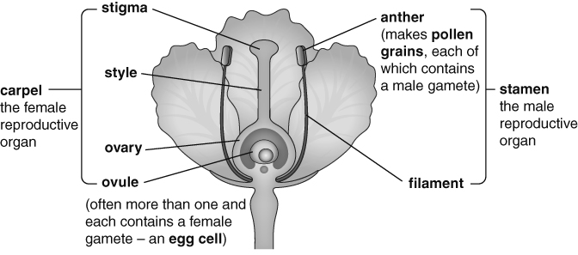
The pollen grains made in the anther need to be carried to the stigma of another flower. They are usually carried by insects or the wind. The carrying of pollen from an anther to a stigma is called pollination.
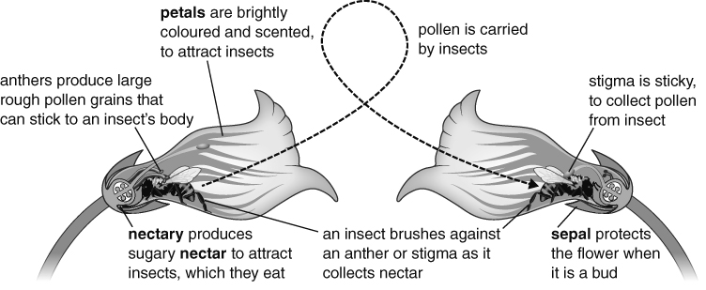
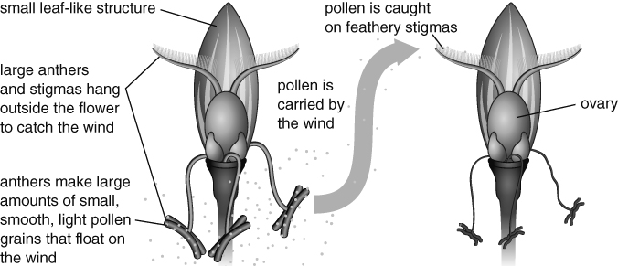
Once on the stigma, a pollen grain grows a pollen tube, which enters the ovule containing an egg cell. The nucleus from the male gamete inside the pollen grain joins with the nucleus inside the egg cell to form a zygote. This is called fertilisation. The zygote grows into an embryo and the ovule becomes a seed, containing the embryo and a food store. | 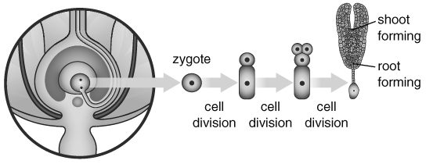
A part of the flower forms a fruit. This is used for seed dispersal, which stops the new plants competing with the parent plants for water, nutrients, light and space.
- Some fruits are eaten by animals and the seeds come out in their faeces (e.g. apples).
- Some fruits are carried on the fur of animals (e.g. burdock).
- Some fruits are carried by the wind (e.g. dandelion).
- Some fruits explode, scattering the seeds (e.g. lupins).
When conditions are right, seeds germinate. The resources needed are water, oxygen and warmth (WOW). Water allows chemical reactions to start, which break down the food store and allows cells in the embryo to swell up. Oxygen is needed for respiration, to release energy from the food store. Warmth is needed to speed up the chemical reactions.
The root grows first then the shoot. Finally new leaves open and photosynthesis can start in the chloroplasts. The glucose from photosynthesis is turned into starch to be stored.
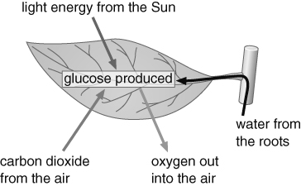
A growing plant needs light, air, water, warmth and nutrients called mineral salts (LAWWN).
Asexual reproduction in plants
Some plants can reproduce using asexual reproduction. This is when one parent plant is able to produce offspring (e.g. by using runners in strawberries or tubers in potatoes).
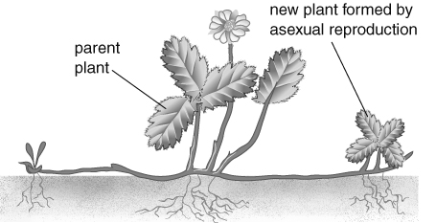
Accuracy, estimates and sampling
We can take a small sample of a larger population and use it to estimate what the larger population is like. Plant populations in an area can be estimated by taking samples using a quadrat. The more samples we take the more accurate the estimate is likely to be but the longer it will take to do.

