Food
We need to eat a wide variety of foods to get all the food substances that we need. When we do this, we are said to have a balanced diet. Carbohydrates, proteins, fats and oils (lipids), vitamins and minerals are nutrients, which means that they provide the raw materials for making other substances that the body needs.
Substance needed | Examples | Why it is needed | Good sources
carbohydrate | starch, sugars | for energy (in respiration) | pasta, bread, rice, potatoes
protein |  | for growth and repair (building new substances) | meat, fish, beans
vitamins | vitamin C | for health | fruits and vegetables (e.g. oranges contain lots of vitamin C)
minerals | calcium | for health | fruits, vegetables and dairy products (e.g. milk contains calcium)
fibre |  | for health (helps to stop  constipation) | wholemeal bread, wholegrain rice, celery and other fibrous vegetables
water |  | for health (water dissolves substances and fills up cells)
We can do tests to find out which substances are in foods. For example, starch makes iodine solution go a blue-black colour.
Nutrition information labels on foods tell us what the food contains. The labels also tell us how much energy is stored in the substances that make up the food. The amount of energy is measured in kilojoules (kJ). The amount of energy a person needs in a day depends on:
- levels of activity (more active people need more energy)
- age (teenagers need more energy from food than adults do)
- whether the person is a girl or a boy (boys need more energy than girls).
Food labels may also have health claims on them, which use persuasive language.
Eating too much or too little can cause problems. Too much fat may cause heart disease and can make people overweight. Very overweight people are obese.
People starve and become weak if they eat too little. Starvation and obesity are both forms of malnutrition. Other forms include deficiency diseases such as scurvy, which is due to a lack of vitamin C.
Digestion
Digestion turns large insoluble substances into small soluble ones. The organs of the digestive system help us digest food. Many of them produce enzymes (substances that are catalysts and help speed up food digestion).
We can use a model to make it easier to think about how enzymes work:
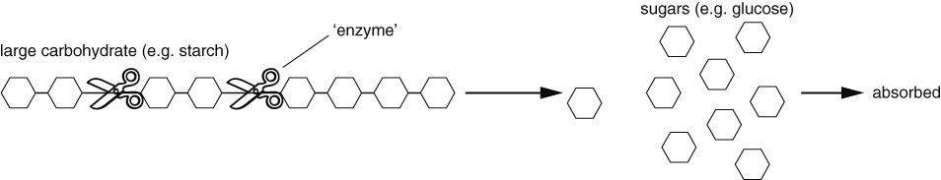
The gut
Food is digested in the gut.
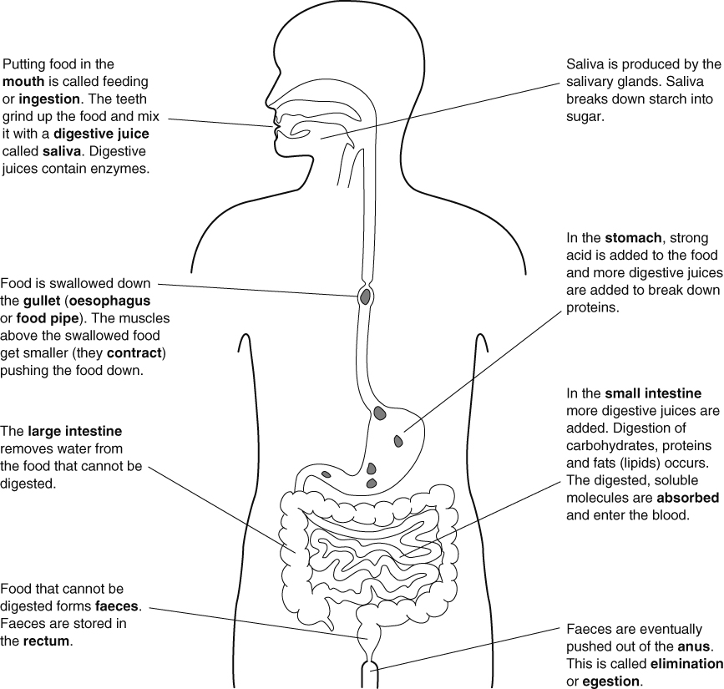
To help absorb the digested food, the wall of the small intestine is folded and covered with villi. The cells have microvilli. These features all increase the surface area. The wall of the small intestine is also only one-cell thick, meaning that it is easy for small molecules to diffuse out of the small intestine and into the blood. The digested food molecules are carried in the blood plasma.
The surface area is the total area of the faces of a three-dimensional object.

