Sound vibrations and waves
Sound is a way of transferring energy. Sounds are made when things vibrate. The vibrations are passed on by particles. Sound therefore needs a medium (substance) to pass on the vibrations, so it can travel through solids, liquids and gases but not through empty space.
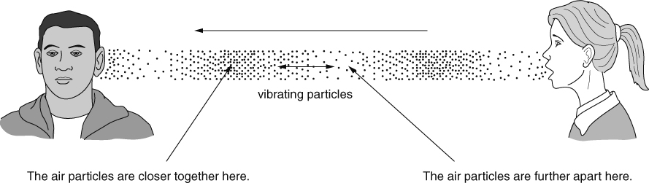
The speed of sound is usually faster through materials in which particles are closer together. Closer particles hit each other more easily and so the energy is more likely to be passed from one particle to the next. Sound travels faster in solids than in liquids, and it travels slowest in gases.
Frequency and amplitude
The frequency of a sound wave is the number of complete waves passing a point each second. The unit of frequency is the hertz (Hz). Pitch is how high or low a sound is. High frequency sounds have a high pitch.
The amplitude of a wave is how far the particles move as the vibrations pass. The larger the amplitude, the louder the sound. The loudness of a sound is also described as the volume or the intensity of the sound.
The loudness of a sound is measured using a sound intensity meter. The units are decibels (dB).
Absorbing, reflecting and transmitting
Sound waves can be reflected by a material. This usually happens if the material is hard. Soft materials absorb some of the sound that reaches them, and transmit only a little.  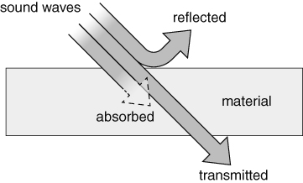 | When a sound wave moves energy from one place to another, we say that the energy has been transferred. The energy spreads out in all directions because the particles move in all directions unless something stops them. This means that the intensity of a sound gets less as you get further from its source.  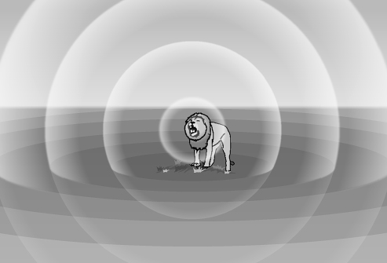
Ears and hearing
Sound is detected by ears and microphones. In a microphone, sound waves make a diaphragm vibrate, and electronics are used to convert the vibrations into changes in an electrical current.
Ears work in a similar way. Sound waves make the eardrum vibrate. The vibrations are passed on by three small ear bones, which also amplify the vibrations (make them bigger). The vibrations pass on to the liquid inside the cochlea, where tiny hairs detect them and send impulses along the auditory nerve to the brain.
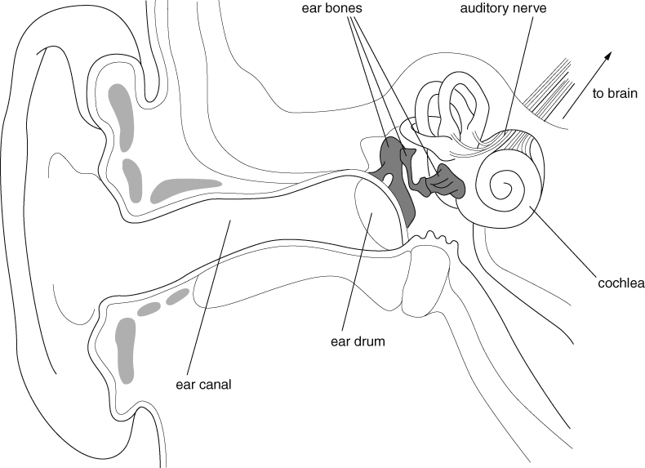
The auditory range of an animal is the range of frequencies of sound it can hear. Animals such as bats and dolphins can hear ultrasounds (sounds with frequencies greater than 20 000 Hz). Some animals can hear infrasounds (frequencies less than 20 Hz).
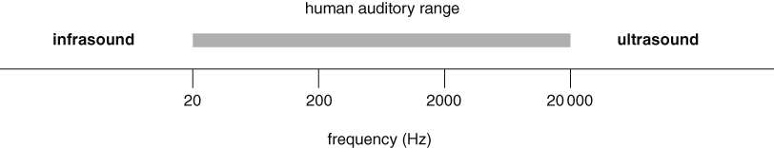
Uses of sound
- Humans and other animals use sound for communication.
- Some animals, such as bats and dolphins, use ultrasound to locate prey and avoid obstacles.
- Humans use ultrasound in sonar, to find the depth of the sea or locate fish or submarines.
- Humans use the energy transferred by ultrasound to clean delicate objects (such as jewellery) or in physiotherapy (to relieve pain or aid healing).
Comparing waves
Transverse waves
- waves on the surface of water
- particles vibrate at right angles to direction wave is travelling
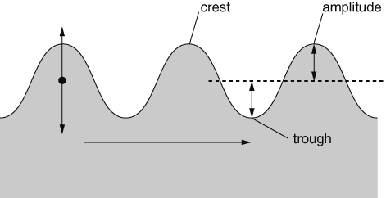
Longitudinal waves
- sound waves
- particles vibrate in same direction as wave travels
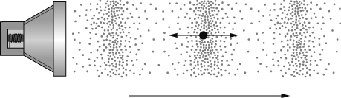
All waves
- transfer energy without transferring matter
- can be reflected, transmitted and absorbed
- can affect other waves by superposition, when their effects can add up or cancel out.
