Forces
Forces are pushes or pulls. Forces can:
- change the shape or size of an object
- change the speed things are moving (make them move faster or slower)
- change the direction of a moving object.
The unit for measuring force is the newton (N).
Friction is a force caused by two things rubbing together. Air resistance and water resistance are kinds of friction.
Solid things, like your chair, push up on you when you sit on them. Upwards forces from water or air are called upthrust. Things float in water because of upthrust.
Contact forces only act when two objects or materials are touching. Examples of contact forces are:  - friction  - air resistance  - water resistance  - upthrust. | Some forces can have an effect without objects touching. They are called non-contact forces. There are three non-contact forces:  - magnetism  - gravity  - static electricity.
Weight and mass
Your mass is the amount of substance in your body. Your mass is measured in kilograms (kg). Your weight is a force caused by gravity pulling on your body. The newton (N) is the scientific unit used to measure forces, and so it is also used as the unit for weight.
Wherever you take an object, its mass will not change but its weight depends on the force of gravity. An object on the Moon would have a smaller weight than on Earth, because the Moon’s gravity is not as strong as Earth’s.
Measuring forces
Elastic materials will stretch with a force and then return to their original shape when the force is taken away. Springs are elastic. The extension of a spring is the difference between its original length and its stretched length.  The extension of a spring is proportional to the force on it. This is called Hooke's Law.  If the spring is stretched too far, the extension stops being proportional to the force. If it is stretched even further, it goes beyond its elastic limit. The spring will no longer return to its original length when the force is removed.  Force meters have springs inside them.  Materials like Plasticine® will stretch with a force but they will not return to their original shape afterwards. Plasticine® is a plastic material. | 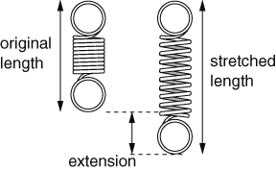  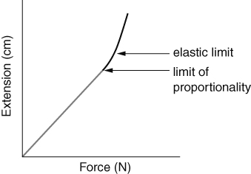
Friction
Friction is a contact force. Friction can:
- slow things down | - produce heat
- wear things away | - cause a noise.
Friction can be increased by using rough surfaces, or by using materials such as rubber that have a lot of friction.
Friction can be reduced by using smooth surfaces, or by lubrication. Oil and grease are examples of lubricants, and help things to move past each other easily.
Pressure
Pressure is the amount of force pushing on a certain area.
For a certain area, the bigger the force, the bigger the pressure. For a certain force, the bigger the area, the smaller the pressure.
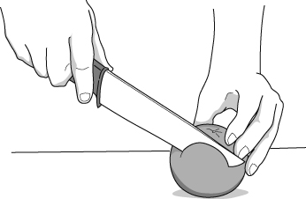  Sharp knife – a small area giving a large pressure. | 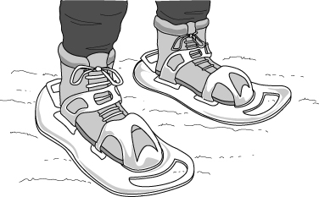  Snow shoes – a large area giving a small pressure.
We can work out the pressure under an object using this formula:
pressure = force ÷ area
Balanced and unbalanced forces
Balanced forces are forces on an object that are the same size but work in opposite directions. If forces are balanced:
- a stationary object stays stationary
- a moving object continues to move at the same speed and in the same direction.
If there are unbalanced forces on an object:
- a stationary object will start to move
- a moving object will change its speed or direction.
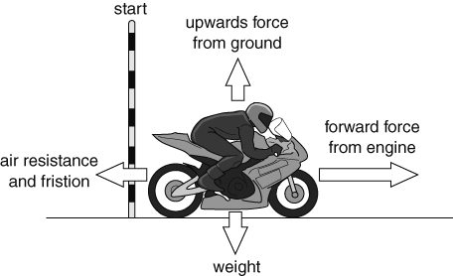  Unbalanced forces – the motorbike will speed up. | 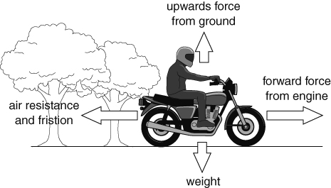  Balanced forces – the motorbike will continue to move at a steady speed.
A car or motorbike uses the energy stored in fuel to move at a steady speed because it needs a force from the engine to balance the forces of air resistance and friction.

