Electrical circuits
Electricity is a flow of charges. Electricity can flow through conductors but not through insulators. Metals are good conductors of electricity. Plastics are good insulators.
For current to flow in a circuit, you need:
- a complete circuit with no gaps
- a cell or power supply.
We can use models to help us to think about electricity and circuits. One model for a circuit is a central heating system. The boiler and pump represent the cell, the pipes represent the wires, and the radiators represent bulbs.
Symbols
Component | Symbol | Component | Symbol | Component | Symbol
cell |  | bulb |  | ammeter
switch |  | resistor |  | voltmeter
Measuring electricity
- Current is the amount of electricity flowing in the circuit.  - It is measured using an ammeter connected in series.  - The units for current are amps (A).  - Voltage provides the ‘push’ and energy.  - It is measured using a voltmeter connected in parallel.  - The units are volts (V). | 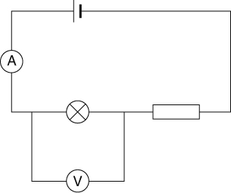
Resistance
The resistance of a circuit is a way of saying how easy or difficult it is for electricity to flow.
- High resistance = hard for electricity to flow = small current.
- Low resistance = easy for electricity to flow = large current.
Thin wires and resistors have high resistances. Thick wires have low resistances.
Series and parallel circuits
Circuits can be series or parallel circuits.
Series circuit  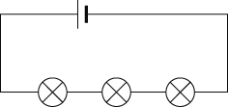 | Parallel circuit  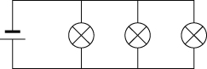
If one bulb breaks, all the others go off.  The current is the same everywhere.  If you put more bulbs in they will be dimmer, because it is harder for the electricity to get through. The resistance of the circuit is higher with more bulbs. | If one bulb breaks, the bulbs in the other branches stay on.  The current splits up when it comes to a branch. The current in all the branches adds up to the current in the main part of a circuit.  If you add more bulbs, they stay bright. It is easier for the current to flow with more branches, because there are more ways for the charges to go.
Safety
Electricity can be dangerous if it is not used properly. It can cause:
- fires
- burns
- shocks that can stop your heart or lungs working.
The wiring in houses is designed to be safe.
- Fuses are used in plugs. They melt if the current gets too high. A fuse has a rating that shows what current it can carry without melting. It is important to use the correct fuse.
- Circuit breakers also cut off the current if it gets too high. They protect the ring mains in buildings (loops of parallel circuits).
- Cables have three colour-coded inner wires. The live and neutral wires are part of the circuit. The earth wire works with the fuse for safety.
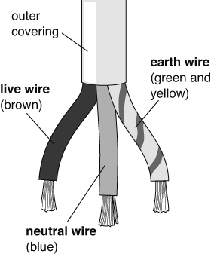 | 