Energy from food
Humans and other animals need energy to live. The energy resource for our bodies is the energy stored in food. We need to choose our food so that we get the right amount of energy.
The unit for measuring energy is the joule (J). There is a lot of energy stored in food, so we usually measure the energy in food using kilojoules (kJ). 1 kJ = 1000 J.
Energy transfers and stores
Energy can be transferred by:
- heating
- light
- sound
- electricity
- forces.
Energy can also be stored in different ways.
Energy stored in… | Commonly called…
the chemicals in food, fuels and batteries | chemical energy
moving objects | kinetic energy
hot objects | thermal energy
objects that are stretched, squashed or twisted | strain energy or elastic potential energy
objects moved to high places | gravitational potential energy
inside the particles that everything is made up from | nuclear energy or atomic energy
Energy is not used up. It can be transferred and stored in different ways, but it cannot be created or destroyed. This is called the law of conservation of energy.
Fuels
Fuels store energy, and this energy is transferred when the fuels burn. Burning fuels are used to heat things.
Fossil fuels:
- are made from plants and animals that were trapped in mud and rocks millions of years ago
- include coal, oil and natural gas
- are non-renewable (they take millions of years to form, and so our supplies will run out)
- produce gases that cause pollution and global warming when burnt
- are relatively cheap to obtain
- originally got their energy from the Sun. The plants that became coal, oil and natural gas got their energy from the Sun, and the animals that became oil and natural gas got their energy from plants, which got their energy from the Sun.
Nuclear fuel is also non-renewable. Nuclear power stations produce dangerous waste materials.
Electricity is not a fuel. It has to be generated using other energy resources.
Making fossil fuels last longer
We can make fossil fuels last longer and help to reduce global warming by using less of them. We could walk or cycle whenever we can, or use a bus instead of using a car. Walking and cycling would make us fitter and healthier, and there would be less pollution if there were not as many cars on the roads. We could also save energy by keeping our houses cooler and putting on more clothes if we are cold instead of turning up the heating.
Renewable energy resources:
- include solar, wind, tidal, wave, biofuels, geothermal and hydroelectricity
- do not produce harmful gases or contribute to global warming
- are often more expensive than using fossil fuels
- will not run out
- are not always available.
Hydroelectricity, geothermal energy and biofuels are available at any time. Tidal power is not available all the time, but we can predict when it will be available. Energy from solar, wind and waves is only available some of the time.
Energy from the Sun
Most of the energy resources we use store energy that originally came from the Sun. Only geothermal power, nuclear power and tidal power do not depend on energy from the Sun.
How energy is transferred to our food:
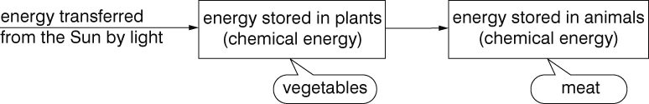
How energy is stored in the wind and in waves:
