Atoms, molecules, elements and compounds
All substances are made up of tiny particles called atoms. Substances can be made of single atoms but they can also be made of atoms bonded together in small groups, called molecules. Substances can also be made of many trillions of atoms all bonded together.  Natural materials can be pure (containing one substance) or mixtures (containing two or more substances which are not joined together). A mixture is formed if elements are mixed without joining.  Elements are simple substances made up of only one kind of atom.  There are about 90 different types of atom found on Earth. Therefore there are about 90 different elements. | 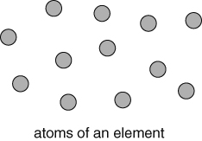  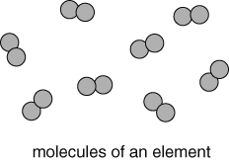  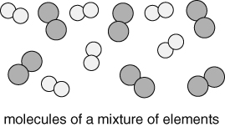
Most substances are compounds, which contain more than one kind of atom (more than one element) bonded (joined) together. | 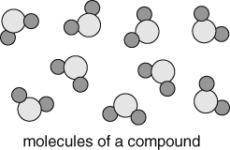
The Earth’s elements
The periodic table lists all 118 known elements.  Element are described by symbols of one or two letters.  The first letter is always a capital letter and the second is always lower case.  The same symbols are used in all countries.  Although there are only about 90 natural elements, there are millions of compounds.  We obtain all the elements and compounds we need for living from the Earth’s atmosphere and crust.  Our resources are limited and some may run out in the near future. We need to take care of our resources, recycle more and make less waste. | e.g. Oxygen = O  Magnesium = Mg  Iron = Fe  Silicon = Si

Metals and non-metals
Elements can be classified as metals or non-metals, depending on their properties.
The common properties of metals are:  - high melting point solids,  - strong and flexible,  - shiny (when polished),  - good conductors of heat,  - good conductors of electricity.  e.g. copper, iron, aluminium, zinc, and tin.  Note: mercury is the only liquid metal. | The common properties of non-metals are:  - low melting point (gases, liquids and solids),  - brittle (when solid),  - not shiny,  - poor conductors of heat,  - poor conductors of electricity.  e.g. sulfur, oxygen, nitrogen, carbon and iodine.
The uses of an element depend on its properties. For example, copper and aluminium are used for electrical cables as they are strong, flexible and conduct electricity very well.
Making compounds
Compounds are formed when elements are mixed and react so that the atoms join together.
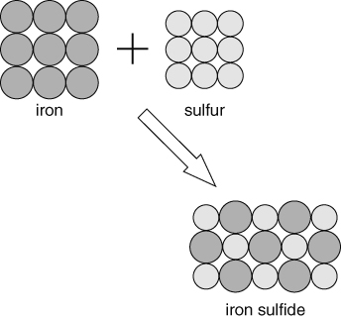 | Naming compounds  If there is a metal in the compound, the name of the metal goes first.  If the compound contains only two elements then one of the element’s name has its ending changed to ‘ide’.  e.g. zinc + oxygen = zinc oxide  iron + bromine = iron bromide  If a compound contains two elements plus oxygen, then the name ending of one of the elements is changed to ‘ate’.  e.g. sodium + carbon + oxygen = sodium carbonate
Chemical reactions  Chemical reactions always form one or more new substances.  Many chemical reactions occur in everyday life, for example, burning, cooking, rusting, digesting food. |  | Typical signs of chemical reaction include:  - a colour change,  - a gas being given off,  - a solid forming in a liquid,  - an energy change.
How chemical reactions start
Some reactions start just by mixing the right substances together.  Heat is often needed to start a reaction, but once started many reactions give out heat.  Others need a continuous supply of energy to keep them going. |  | e.g. acid and alkalis  e.g. burning natural gas  e.g. breaking down metal ores

Modelling chemical reactions using word equations
reactants → products
e.g. zinc + chlorine → zinc chloride
tin carbonate → tin oxide + carbon dioxide
Thermal decomposition reactions involve breaking down a single compound using heat.  Heating copper carbonate produces copper oxide and carbon dioxide.  Thermal decomposition reactions are used in industry to extract metals. | 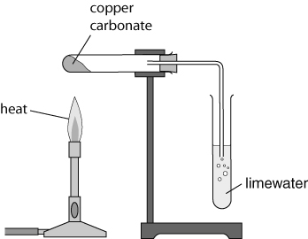
Sorting and presenting data  The way data is sorted and presented depends on the type of variable and what you want to show.  Tables – show values and order.  Bar charts – compare differences between qualitative/discrete variables.  Line graphs – shows trends between variables.  Scatter graphs – look for relationships between quantitative variables.  Pie charts – shows proportions of a total.  Note: Qualitative data = words. Quantitative data = numbers.  Discrete data = only certain number values.
  Gases in air | %
  nitrogen | 78
  oxygen | 21
  other gases | 1
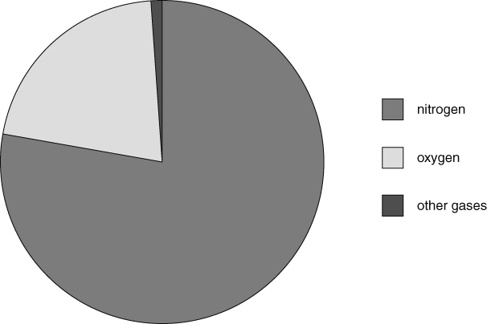
Pie chart of gases in air

