The particle theory
A scientific method describes how scientists try to explain the world around them. It usually starts with some observations, which generate a question. Scientists may then follow a series of unbiased steps to answer the questions. These steps could include the following:
- thinking up an idea or using existing ideas that would explain the observations. These ideas are called hypotheses.
- using the hypothesis to make a prediction about the hypothesis.
- testing the prediction by experiment, and collecting data.
- checking the data to see if it matches the prediction.
- using the data as evidence to support the hypothesis (or prove it is wrong).
- forming a theory if the hypotheses have been tested many times and shown, by the evidence, to be correct. The particle theory is an example.
The different properties of solids, liquids and gases can be explained by the particle theory
(or particle model). Solids, liquids and gases (the three states of matter) need to be handled and stored differently because of these different properties.
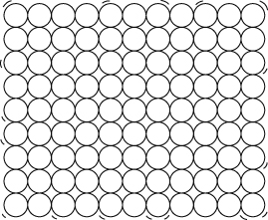  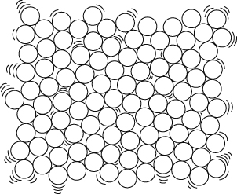  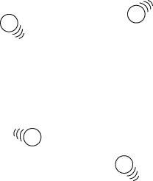 | Solids  - Solids are made up of particles that are very close together. (Strong forces of attraction hold the particles together.)  - The particles in solids vibrate in fixed positions.  - The shape and volume of solids do not change.  - Solids cannot be squashed and do not flow.  Liquids  - Liquids are made up of particles that are fairly close together. (Quite strong forces of attraction hold the particles together.)  - The particles in liquids are able to move past each other.  - Liquids have a fixed volumes but their shape can change to fit the container as they flow easily.  - Liquids cannot be easily compressed (squashed).  Gases  - Gases are made up of particles that are well spread out. (There are only weak forces of attraction between the particles.)  - The particles in gases move about freely in all directions.  - The shape and the volume of gases can change as they flow very easily and spread out.  - Gases can be compressed (squashed) quite easily.
Brownian motion
When pollen grains in water are observed through a microscope they are seen to move jerkily in different directions. This is called Brownian motion. It is caused by water particles, which are moving all the time, hitting the pollen grains. The pollen grains are small enough so that when many water particles hit one side of the grain, the grain is moved in that direction.
Brownian motion provides evidence to support particle theory.
Diffusion
Diffusion is said to have occurred when chemicals mix together without anything moving them. Diffusion occurs because particles in a substance are always moving around. Diffusion is fastest in gases, and slower in liquids. | 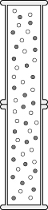
Dilution
When you add water to orange squash you dilute it. The colour becomes paler because the orange coloured squash particles are spread out more among the water particles.
Pressure in gases
Pressure is caused by particles hitting the walls of the container they are in. The pressure may increase because:
- the container has been squashed, making the volume smaller so that the particles will be hitting the walls more often.
- the number of particles has been increased, so that there are more particles moving around to hit the walls.
If the particles are in a flexible container, like a balloon, an increase in pressure inside the container can make the volume increase. If the pressure becomes too great, the balloon will burst.
Air pressure is the pressure caused by air particles around us. Air pressure lets us suck things up using a straw and also causes a container to collapse if the air is sucked out. If all the air is sucked out of a container, you get a vacuum – nothingness.
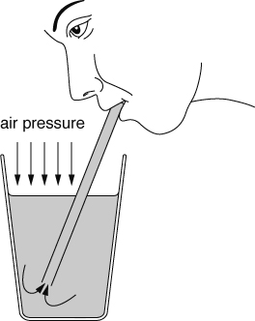 | 