Mixtures
A mixture contains two or more substances jumbled together. There are different kinds of mixture:
- suspension: the solids settle out of the mixture over time.
- colloid: the solid pieces are smaller so they don't settle out, and the mixture looks cloudy or opaque.
- solution: the solids break up into such small pieces that they are not visible, and the mixture is transparent.
Solutions
Some solids dissolve in water to make a solution. These solids are soluble. A solution is made from a solute (usually a solid) and a solvent (liquid). Some gases, such as oxygen and carbon dioxide, can also dissolve in water.
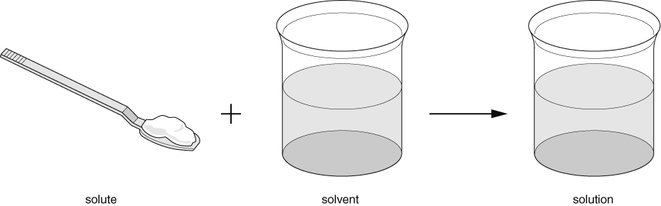
Substances that do not dissolve in a solvent are insoluble. When an insoluble substance is mixed with water, the mixture formed may be a suspension or a colloid.
The total mass of a solution equals the mass of solvent added to the mass of solute.
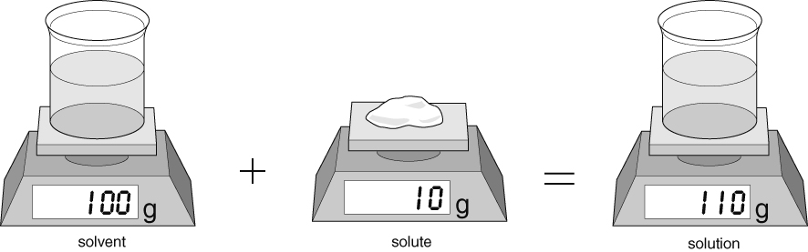
Water dissolves many different solutes. Other liquids (e.g. white spirit, ethanol) can also be used as solvents. Solutes that are insoluble in water may dissolve in other solvents.
If you keep adding solutes to a solvent, you will get to a point where no more will dissolve. The solution is saturated with solute. More solid may dissolve if you add more solvent (e.g. water) or increase the temperature.
The solubility of a solute is the amount that will dissolve in a fixed amount of solvent at a particular temperature.
Mixtures and solutions can be separated using different methods.
Method | Used to separate | Apparatus used | Examples
filtering (filtration) | solids from a suspension (i.e. large pieces of solids that have not dissolved in a liquid) | 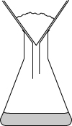 | - sand from a mixture of sand and water
evaporation | solid substances from a solution or colloid | 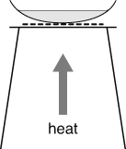 | - salt from a salt solution
distillation (evaporation followed by condensation) | liquid from a mixture | 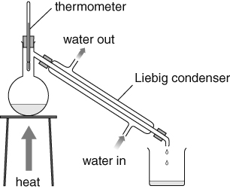 | - pure water from a salt solution
chromatography | individual solutes from a mixture of solutes in a solvent | 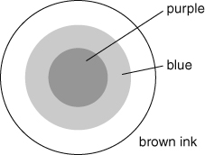 | - colours found in ink
Interpreting a chromatogram
Chromatograms help to identify substances in a mixture.  This paper chromatogram shows that A, B, C and D are all single substances and that X is a mixture of C and D. | 
Evaporation and boiling
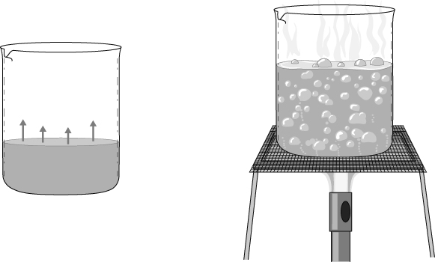
Evaporation is when a liquid turns to a gas at its surface.  - It happens at any temperature.  - It is faster when the temperature is higher. | When a liquid boils, all the liquid is trying to turn into a gas at the same time.  - Boiling happens at the liquid's boiling point.  - Gas formed inside the liquid makes bubbles that rise to the surface.  - The boiling point of pure water is 100 °C.
Heating with a Bunsen burner
The air hole of a Bunsen burner can be adjusted to give different kinds of flame. Each kind is useful for different things.
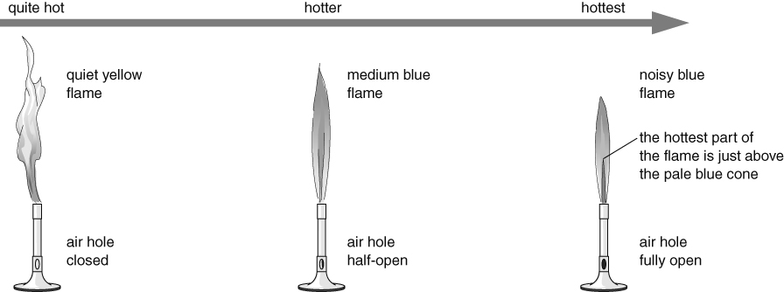
Safety flame: should always be used when not heating. | This flame is used for gentle heating. | This flame is used for rapid heating.
Hazards and risks
- A hazard is something that could cause harm.
- A risk is how likely it is that the hazard will cause harm.
- You should always plan to minimise risks in experiments.
Example of hazard | How to reduce the risk from the hazard
Burns or scalds from apparatus heated by a Bunsen burner. | Use heat-resistant gloves or tongs to touch apparatus.
Spitting liquid when heating to dryness. | Wear eye protection and make sure heat is turned off before the solution is completely dry.
Shaking of distillation flask by bubbling liquid. | Add anti-bumping granules to liquid to prevent large gas bubbles forming.
Writing a good method
Here is a method for lighting a Bunsen burner safely. The labels on the right show how to write a good method.
Method
The instructions are written as a set of steps in the correct order, or sequence, for carrying out the experiment.
- Check the gas hose for breaks or holes and return the Bunsen burner and hose to your teacher if it is damaged.
- Tie back loose hair and any loose clothing, such as a tie or scarf.
Each step describes one action during the experiment.
- Remove everything except what is needed for the experiment from your working area.
- Wear eye protection.
Use imperative verbs (command words) to keep the sentence structure simple and the language clear.
- Place the burner on a heat-resistant mat
30–40 cm from the edge of the bench.
- Make sure the air hole of the Bunsen burner is closed.
- Hold a lit splint or a long-armed sparker or lighter about 2 cm above the top of the Bunsen burner.
Use the correct names for apparatus, and correct science terms where appropriate.
- Turn on the gas at the gas tap to light the burner.
When you write up your method in your report at the end of the experiment, change the verbs to the past tense. For example:
- I made sure the air hole of the Bunsen burner was closed.

