Locomotor system
The locomotor system consists of bones and muscles and lets you move.  Bones are organs that form the skeleton, which:  - protects some organs (e.g. the ribs and sternum protect the lungs; the skull protects the brain)  - supports your body (e.g. the vertebrae in your ‘backbone’ hold you up straight)  - allows you to move (using muscles at your joints).  Bones are hard (to withstand knocks and pressure) and light (so they are easy to move). Many have a hollow centre containing bone marrow, where blood cells are made. | 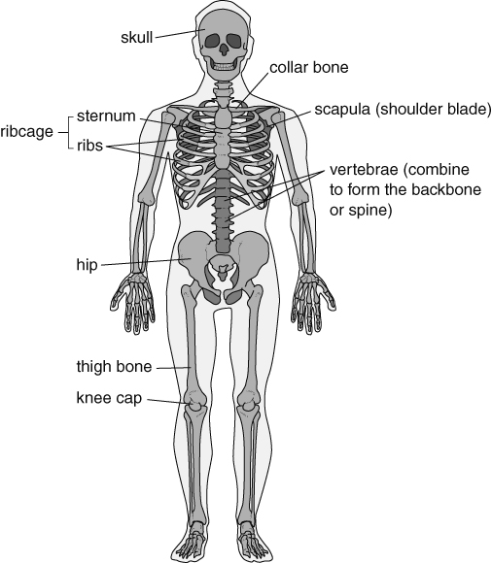  The human skeleton.
Muscle action
Muscles cannot push and so bones need pairs of muscles (antagonistic pairs) to pull them in opposite directions. One muscle contracts (gets shorter and fatter) to pull a bone. At the same time, the other muscle in the pair relaxes.
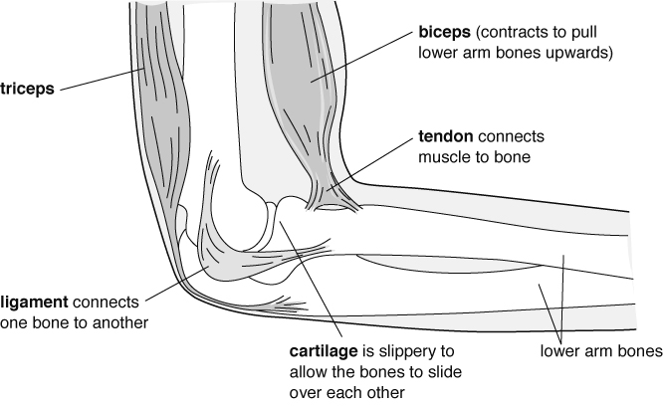
The elbow joint is a flexible joint (whereas the bones in the skull meet at fixed joints).
Muscles are controlled by the nervous system. Impulses from the brain travel down the spinal cord and along nerves to muscles.
Muscle cells are adapted to their function by containing strands that can shorten to produce a pulling force. This requires energy from respiration.
The oxygen and nutrients (from food) required for respiration are carried to the muscles in the blood. Nutrients are carried in the plasma, while oxygen is carried on red blood cells. Blood also contains white blood cells, which attack micro-organisms.
Breathing
The gas exchange or breathing system allows air to enter and leave the lungs, so that oxygen can get into the blood and carbon dioxide can leave the blood. Oxygen for respiration leaves the lungs and enters the blood. Carbon dioxide (a waste product from respiration) leaves the blood and enters the air in the lungs. Carbon dioxide is excreted when you exhale.  Breathing is the movement of the muscles in your diaphragm and between the ribs, which cause the changes in the volume of the lungs. Ventilation is the movement of air into and out of the lungs as breathing occurs. | 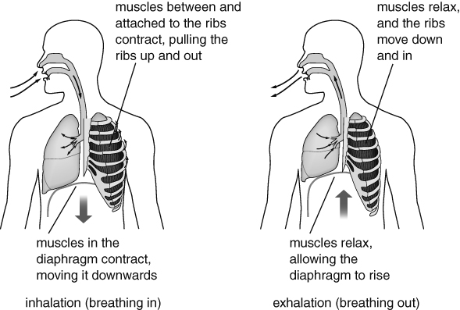  Diagram showing breathing.
Circulation  Blood is carried to the heart by veins, where it enters the chambers of the heart. The blood is then forced back out when the heart muscle tissue contracts. The pumping of the heart can be felt in arteries as a pulse.  Arteries are connected to veins by capillaries, which are blood vessels with very thin walls that allow oxygen and nutrients to leave the blood to get to the cells in tissues. Carbon dioxide from the cells can easily get into the capillaries. | 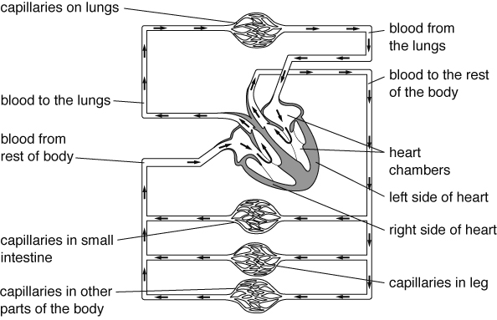  Some of the circulatory system.
Drugs
Drugs are chemicals that affect how the body works. Some can damage your organs (e.g. the liver), particularly if they are abused. Some drugs are addictive.
Medicines (e.g. antibiotics) are drugs that can help people who are suffering from diseases. Recreational drugs are drugs that people take because they like the effect that they have on their bodies (e.g. caffeine in coffee and alcohol, which are both legal drugs). Some are illegal drugs (e.g. heroin and ecstasy) because they have very harmful side-effects.
Drugs that slow down the nervous system are called depressants. Alcohol is a depressant. It alters behaviour and slows reaction times. Drugs that speed up the nervous system are called stimulants (e.g. caffeine).

