Reproduction
Reproduction produces new living things (offspring). Two parents are needed for sexual reproduction.  Males and females have reproductive systems, which contain reproductive organs to allow them to reproduce. The ovaries and testes produce gametes or sex cells.  Sexual intercourse in mammals  During sexual intercourse, semen (sperm cells mixed with special liquids from the glands) is forced out of the penis and into the top of the vagina. This is called ejaculation. The semen travels into the top of the uterus and the sperm cells then swim down the oviducts.  Sperm and egg cells are adapted to their functions. A sperm cell is much smaller than an egg cell. | 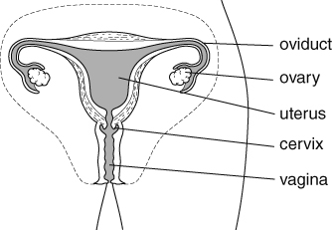  The female reproductive system
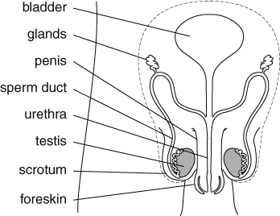
The male reproductive system
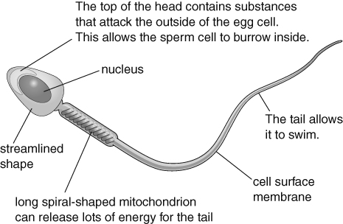 | 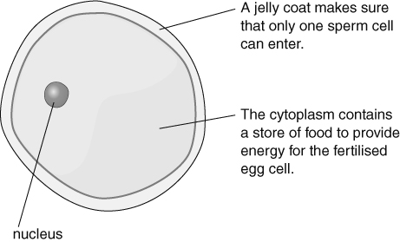
Pregnancy in mammals
If an egg cell meets a sperm cell in an oviduct, fertilisation can occur (the nuclei from the two cells fuse). The fertilised egg cell divides to form a ball of cells (an embryo). The embryo travels to the uterus where it sinks into the uterus lining (implantation). The woman is now pregnant. Once the embryo has developed all its organs it is called a fetus. It takes about 40 weeks (9 months) for a human fertilised egg cell to grow into a baby ready to be born. This time is called the gestation period. | 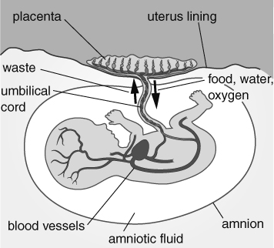
While inside the uterus, the fetus is supplied with oxygen and food by the placenta. The placenta also gets rid of waste (especially carbon dioxide) from the fetus. The umbilical cord connects the fetus to the placenta.
If a mother smokes, drinks too much alcohol or takes drugs while pregnant, she might damage the baby. The baby might be premature.
Birth in mammals
- The uterus starts contractions and the woman goes into labour.
- The muscles of the cervix relax.
- The baby is pushed out head first through the cervix and the vagina.
- The baby starts to breathe and the umbilical cord is cut. The scar left behind is the navel.
- Then the placenta is pushed out of the uterus. This is the afterbirth.
The mother’s breasts contain mammary glands that produce milk to feed the baby. Breast milk contains all the nutrients that a baby needs and antibodies, which help destroy micro-organisms that might cause diseases.
Growing up
The stages through which an organism goes as it grows and develops are its lifecycle. In the human lifecycle, a baby grows into a child. Between the ages of 10 and 14 years, most children start to go through puberty. During puberty, sex hormones cause big physical changes to occur. Adolescence is the time when emotional as well as physical changes occur. It ends at about 18.
Changes in boys | Changes in girls
- hair grows under arms, on face and on chest | - hair grows under arms
- pubic hair grows | - pubic hair grows
- shoulders get wider | - hips get wider
- body smell increases | - body smell increases
- testes start to make sperm cells | - ovaries start to release egg cells
- testes and penis get bigger | - breasts develop
- voice deepens (‘breaks’)
After puberty, animals are able to sexually reproduce. Men produce sperm cells for the rest of their lives. Women stop releasing egg cells at the age of 45–55 and this is called the menopause.
In all mammals fertilisation happens inside the female. This is called internal fertilisation. In some animals (e.g. frogs, fish) fertilisation happens outside the female (external fertilisation).
The fertilised egg cells of many animals also grow and develop outside their parents. This is called external development. Amphibians, birds and fish use external development. Humans use internal development and produce fewer offspring than animals using external development because the growing embryos are protected inside the mother.

