Cells, tissues, organs and organ systems
All organisms carry out seven life processes (movement, reproduction, sensitivity, growth, respiration, excretion, nutrition). All organisms are made from cells:
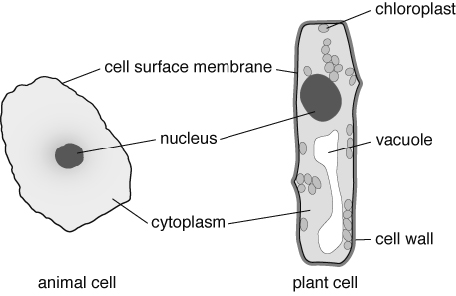
Cell part | Function
cell surface membrane | keeps cell together and controls what goes into and out of the cell
nucleus | controls the cell
cytoplasm | where activities happen, including respiration (which occurs in mitochondria)
chloroplast | contains chlorophyll to trap sunlight for photosynthesis
cell wall | made of cellulose and provides support
vacuole | storage space
A microscope is used to magnify tiny things such as cells.
total magnification = magnification of objective lens × magnification of eyepiece lens.
The object you look at is the specimen. It has to be thin to let light get through it. It is placed with a drop of water onto a slide. A coverslip is carefully lowered on top, to stop the specimen drying out, hold it flat and stop it moving. A stain can be used to help you see parts of the cell.
To use a microscope:  A Place the smallest objective lens over the hole in the stage.  B Turn the focusing wheel to move the objective lens close to the stage.  C Place the slide on the stage.  D Adjust the light source or mirror.  E Look into the eyepiece lens.  F Turn the focusing wheel until what you see is in focus. | 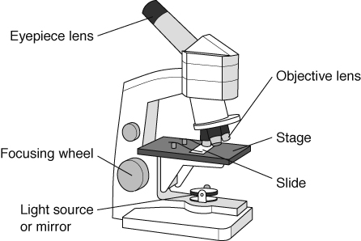

Some cells are specialised and have special functions.
In animals |  | In plants
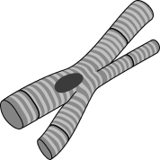  Muscle cells shape to move things. |  | 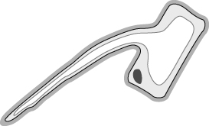  Root hair cells take in water.
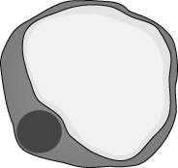  Fat cells in animals store fat. |  | 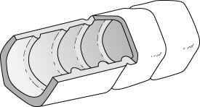  Xylem cells carry water.
A group of cells that are the same, all doing the same job, is called a tissue (e.g. muscle tissue).  A group of different tissues working together to do an important job is an organ. For example, the heart is an organ and is made of muscle tissue and nerve tissue. Organs have important functions. | 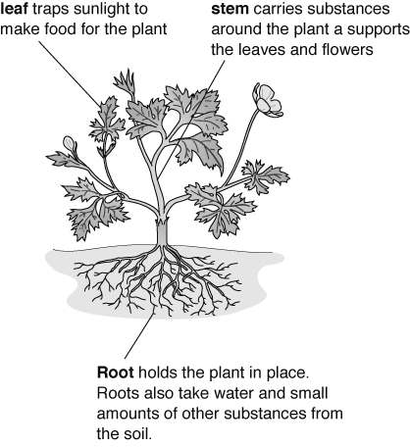
Organs often work together in organ systems.
Organ system | Organs | Job
breathing system | windpipe (trachea), lungs | takes air into the body and gets rid of waste gases
circulatory system | heart, blood vessels | carries oxygen and food around the body
digestive system | mouth, gullet, stomach, intestines | breaks down food
nervous system | brain, spinal cord, nerves | carries signals around the body
urinary system | bladder, kidneys | gets rid of waste
locomotor system | muscles, bones | allows movement
water transport system (plants) | roots, stem, leaves | carries water up a plant

