Name Class Date
On your answer sheet, write in or circle the correct letter for each question.

7Ca
- Which is a waste product of human respiration?
A nitrogen B oxygen
C carbon dioxide D argon
- What is the organ labelled W?
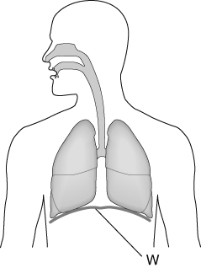
A diaphragm B lung
C trachea D oesophagus
- When you inhale, what do the muscles next to the ribs do?
- Contract to lift the ribs.
- Relax to lift the ribs.
- Contract to lower the ribs.
- Relax to lower the ribs.
- What happens to a lot of the oxygen in the lungs?
- It is turned directly into nitrogen.
- It is turned directly into carbon dioxide.
- It enters the blood.
- It catches fire.
7Cb
- Sandy counted 25 beats of her pulse on her wrist in 20 seconds. What was her pulse rate in beats per minute?
A 25 beats B 45 beats
C 75 beats D 500 beats

- What happens to push blood out of the heart?
- The heart muscle contracts to reduce the volume in the heart chambers.
- The heart muscle relaxes to reduce the volume in the heart chambers.
- The heart muscle contracts to increase the volume in the heart chambers.
- The heart muscle relaxes to increase the volume in the heart chambers.
- How is oxygen mainly carried by the blood?
A in the plasma B on red blood cells
C on white blood cells D in veins
- Capillaries are adapted to their function by:
- being hollow so that they can carry air.
- having thick walls so that oxygen and nutrients cannot escape.
- having thin walls so that oxygen and nutrients can get out of the blood.
- having holes in the walls so that blood can drain out of them.
7Cc
- The drawing shows the bones in a human skeleton.
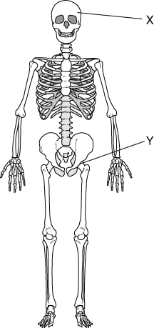
What is bone X used for?
A protection B movement
C thinking D growing hair
- Look at the skeleton in the last question again. What is the name of joint Y?
A elbow B knee
C shoulder D hip
- Larger bones often have spaces inside them so that:
- they can be filled with blood.
- they can be filled with air.
- they can be broken more easily.
- they are lighter to move.
- In a joint, the part that joins a muscle to a bone is called a:
A ligament. B tendon.
C cartilage. D cartridge.
7Cd
- Ravi is measuring the force of his hand grip. The units he should use to record his measurements are:
A kilograms. B metres.
C beats per minute. D newtons.
- Which part of the diagram below causes a force to move the lower arm in the direction shown?
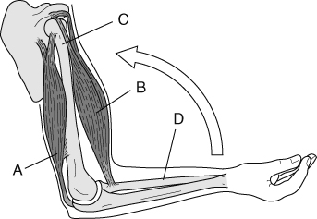
- When standing, your quadriceps muscle swings your lower leg forwards but not backwards. Why?
- Your lower leg can’t swing backwards.
- The quadriceps muscle can only pull in one direction.
- The quadriceps muscle can only push in one direction.
- The quadriceps muscle is too weak.
- The action of muscles is controlled by:
- blood from the circulatory system.
- thoughts from the brain.
- movements of the locomotor system.
- impulses from the nervous system.
7Ce
- A drug is:
- a substance that affects how the body works.
- any type of medicine.
- a substance that harms the body.
- any type of addictive substance.
- Heroin is:
- a recreational, stimulant drug.
- a recreational, depressant drug.
- a recreational, legal drug.
- both a stimulant and a depressant.
- Which organ is most likely to be damaged by the abuse of any drug?
A lungs B kidneys
C liver D ovaries
- A depressant is:
- a chemical that speeds up your nervous system.
- a chemical that makes you feel sad.
- a chemical that slows down your nervous system.
- a TV soap about day-to-day life.

