Name Class Date
- State one piece of evidence that can be used to support the idea that bones or muscles can change throughout someone’s life.

- Tyler measured the force of his grip. Which is the most likely reading? Tick one.
 190 kg  190 N  1 lb
 20 000 N  5 seconds  18 mg
- Look at the drawing of the inside of the arm.  a What are parts X and Y both types of?  b What are the humerus, radius and ulna examples of?  c Describe what happens to the shape of part X when it contracts.  d Which part, X or Y, has to contract to pull up the lower arm? | 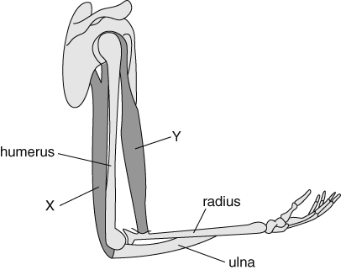
e What are the names of parts X and Y?
X is
Y is
f Why does moving the lower arm need both parts X and Y?  - The nervous system is shown in the drawing.  a On the diagram, draw an arrowed line to show where electrical messages to the muscle come from.  b What are these electrical messages called? | 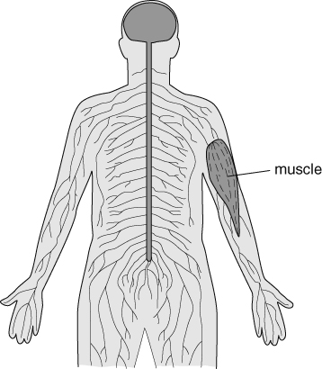
I can…
- explain how antagonistic pairs of muscles operate and are controlled to allow movement.

